Triangle

Definition
# Source: AI Source: Provided by: [Data Path: Persons Table -> ID Column: 1, Name_En Column: Motasem Essam] -> From: [ChatGPT] on [7/25/2026]
A triangle is a closed two-dimensional polygon formed by three line segments connecting three non-collinear points.
A triangle has:
- 3 sides
- 3 vertices
- 3 interior angles
If the vertices are $A$, $B$, and $C$, the triangle is written as:
$$\boxed{△ABC}$$
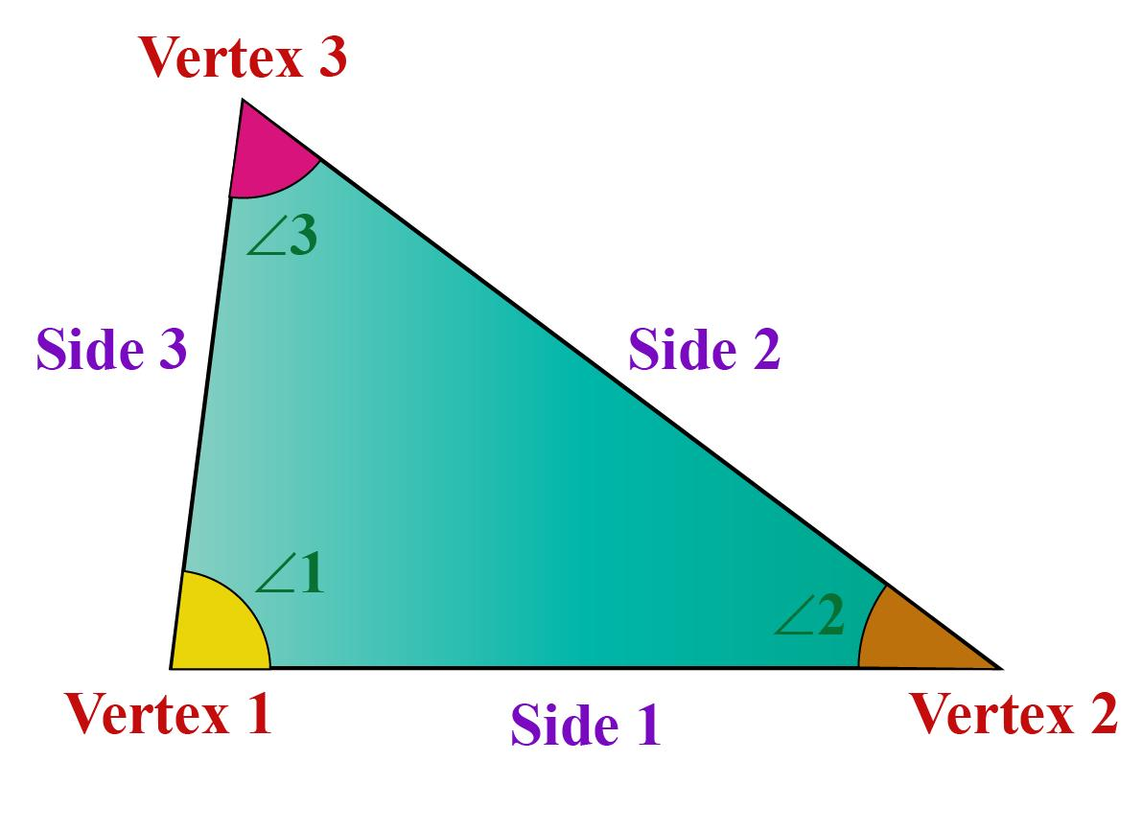
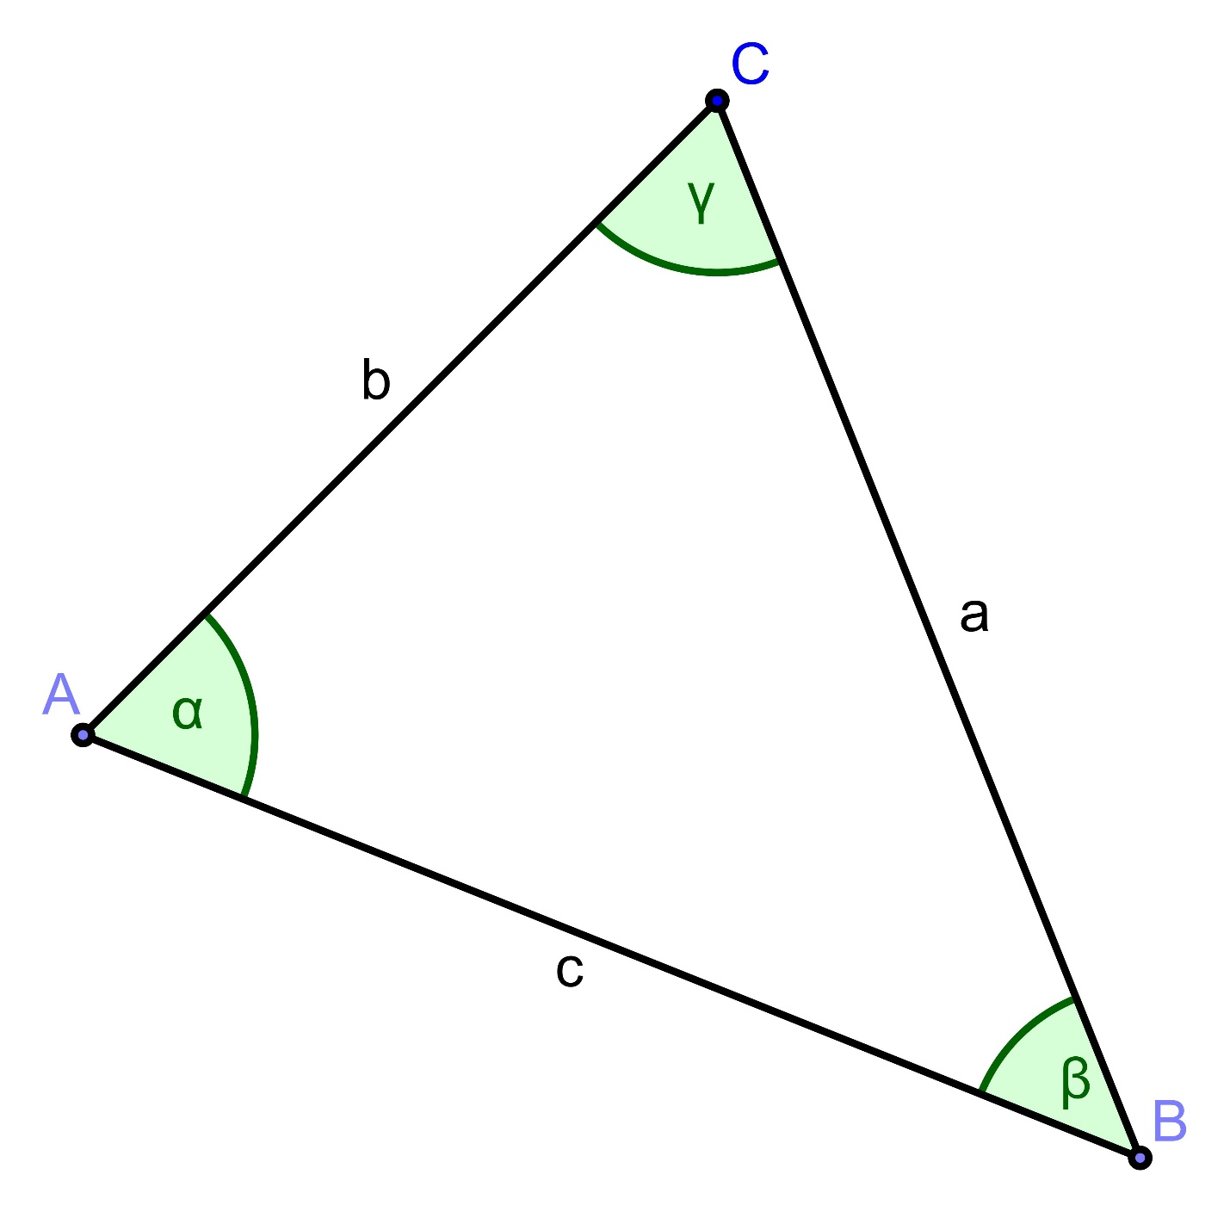
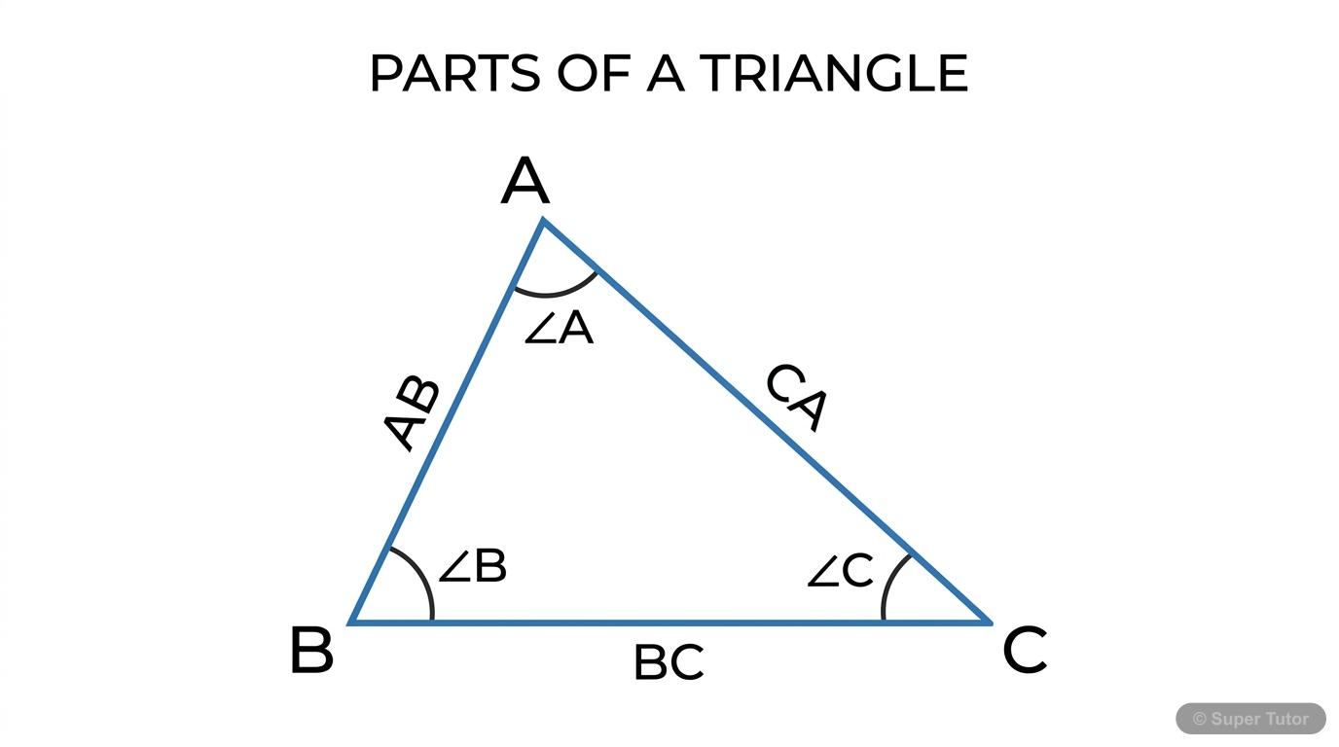
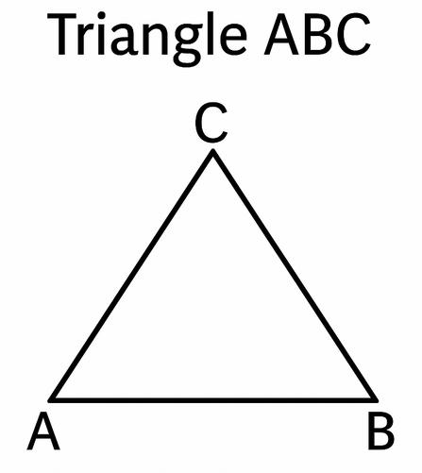
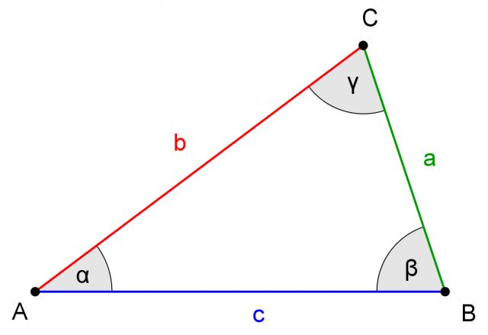

Purpose
# Source: AI Source: Provided by: [Data Path: Persons Table -> ID Column: 1, Name_En Column: Motasem Essam] -> From: [ChatGPT] on [7/25/2026]
Triangles are used to:
- Study two-dimensional geometric figures.
- Measure angles and side lengths.
- Calculate areas and perimeters.
- Analyze geometric relationships.
- Solve distance and height problems.
- Study congruence and similarity.
- Support trigonometry.
- Construct and analyze geometric shapes.
- Support engineering, architecture, and surveying.

Fundamental Elements of a Triangle
# Source: AI Source: Provided by: [Data Path: Persons Table -> ID Column: 1, Name_En Column: Motasem Essam] -> From: [ChatGPT] on [7/25/2026]
Every triangle consists of three fundamental types of components:
1. Vertices
The vertices are the three points where the sides meet.
For:
$$△ABC$$
the vertices are:
$$\boxed{A, B, C}$$
2. Sides
The three line segments are:
$$\boxed{\overset{‾}{AB}, \overset{‾}{BC}, \overset{‾}{CA}}$$
3. Angles
The three interior angles are:
$$\boxed{∠A, ∠B, ∠C}$$

Triangle Angle Sum
# Source: AI Source: Provided by: [Data Path: Persons Table -> ID Column: 1, Name_En Column: Motasem Essam] -> From: [ChatGPT] on [7/25/2026]
The three interior angles of every triangle add up to:
$$\boxed{∠A+∠B+∠C={180}^{∘}}$$
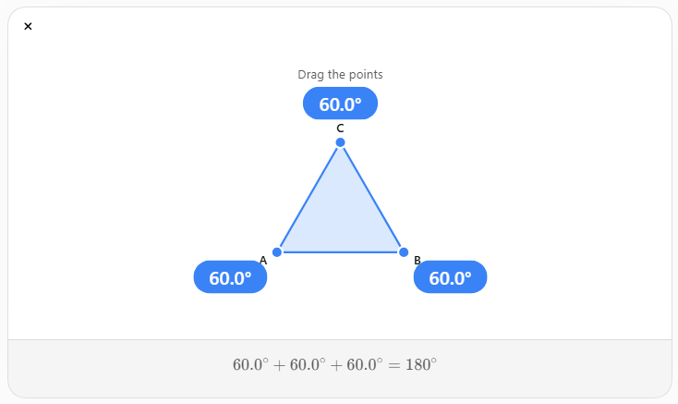
For example, if:
$$∠A={50}^{∘}$$
and:
$$∠B={60}^{∘}$$
then:
$$∠C={180}^{∘}-{50}^{∘}-{60}^{∘} \\ \boxed{∠C={70}^{∘}}$$

Classification of Triangles
Triangles can be classified according to:
- Side lengths
- Angle measures

Types of Triangles by Sides

1. Equilateral Triangle
# Source: AI Source: Provided by: [Data Path: Persons Table -> ID Column: 1, Name_En Column: Motasem Essam] -> From: [ChatGPT] on [7/25/2026]
An equilateral triangle has three equal sides.
$$\boxed{a=b=c}$$
All three interior angles are also equal:
$$\boxed{{60}^{∘}, {60}^{∘}, {60}^{∘}}$$
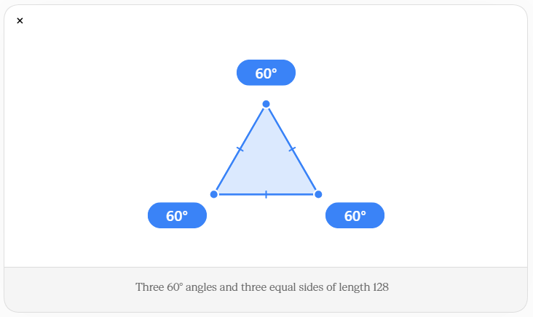
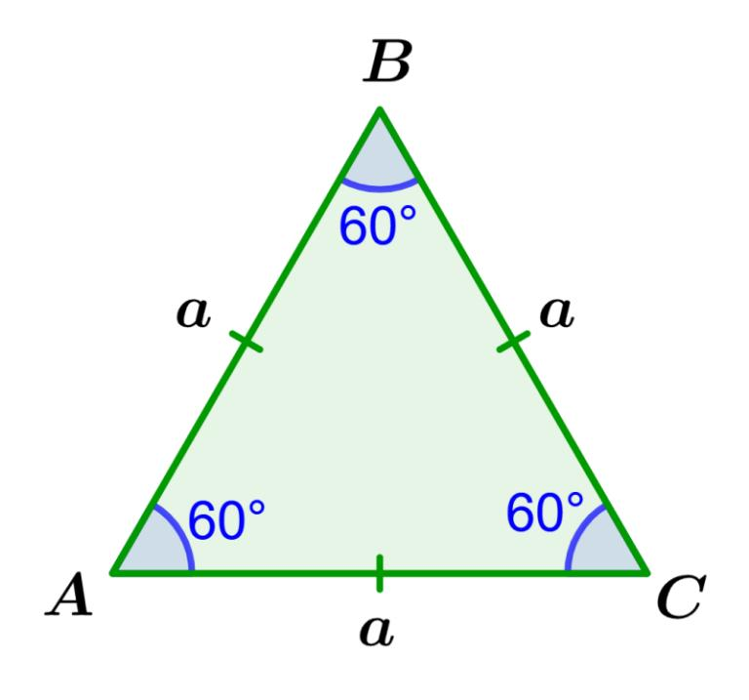
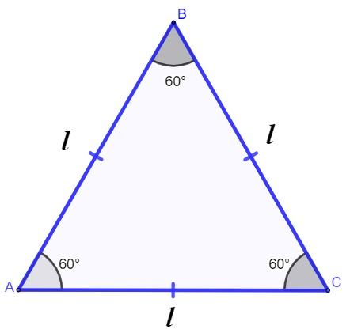
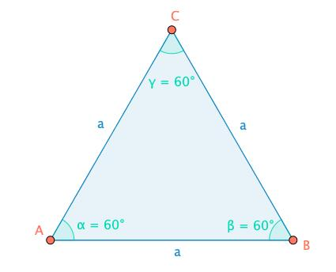
Properties
- 3 equal sides
- 3 equal angles
- Each angle is ${60}^{∘}$
- 3 lines of symmetry
- Rotational symmetry of order 3

2. Isosceles Triangle
# Source: AI Source: Provided by: [Data Path: Persons Table -> ID Column: 1, Name_En Column: Motasem Essam] -> From: [ChatGPT] on [7/25/2026]
An isosceles triangle has at least two equal sides.
For example:
$$\boxed{AB=AC}$$
The angles opposite the equal sides are also equal.
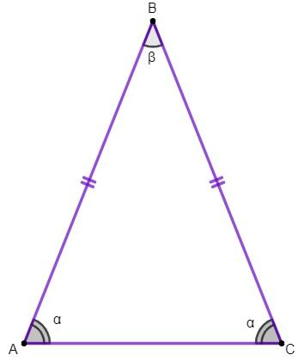
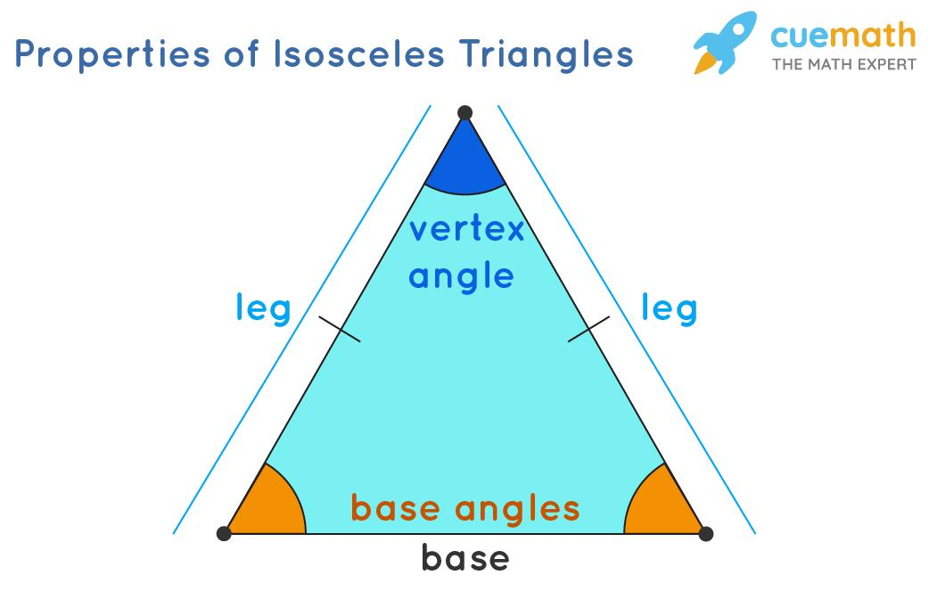
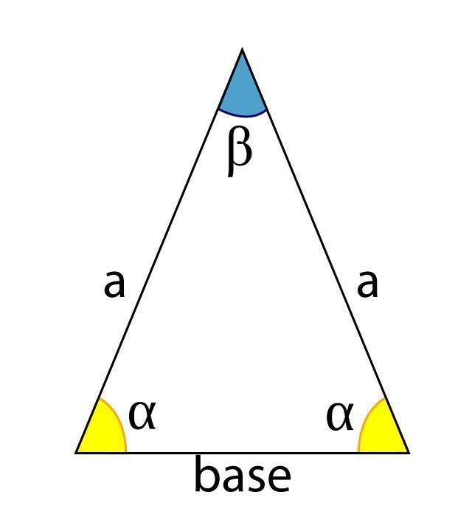
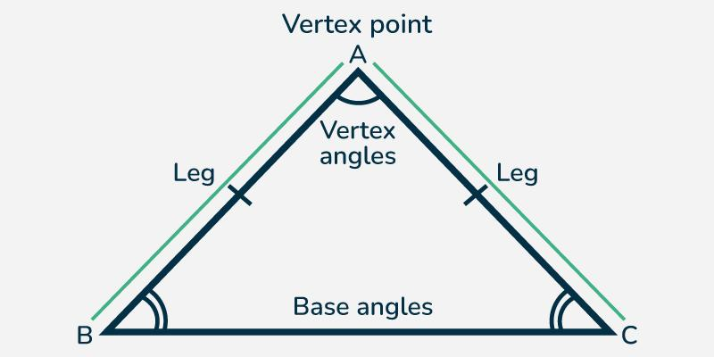
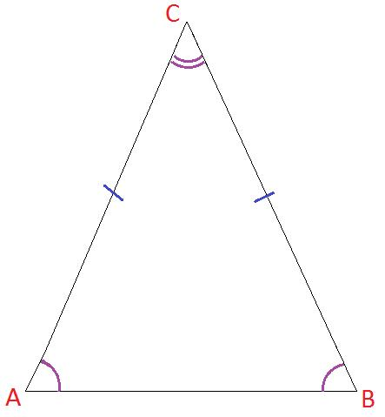
Properties
- At least 2 equal sides
- At least 2 equal angles
- Has at least 1 line of symmetry

3. Scalene Triangle
# Source: AI Source: Provided by: [Data Path: Persons Table -> ID Column: 1, Name_En Column: Motasem Essam] -> From: [ChatGPT] on [7/25/2026]
A scalene triangle has three different side lengths.
$$\boxed{a≠b≠c}$$
Its three angles are also different.
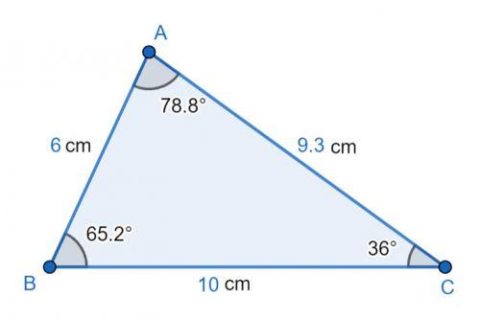
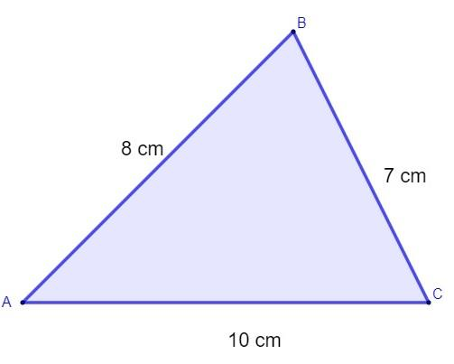
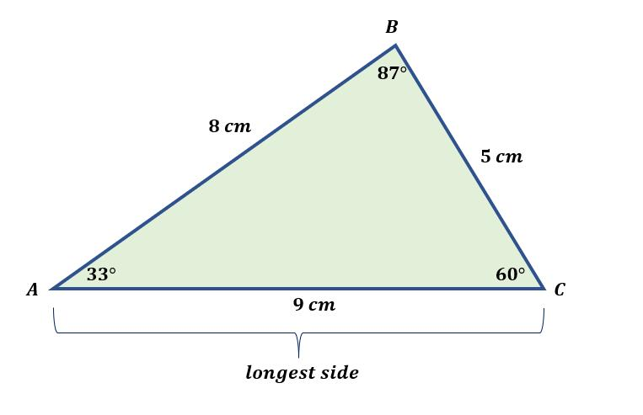
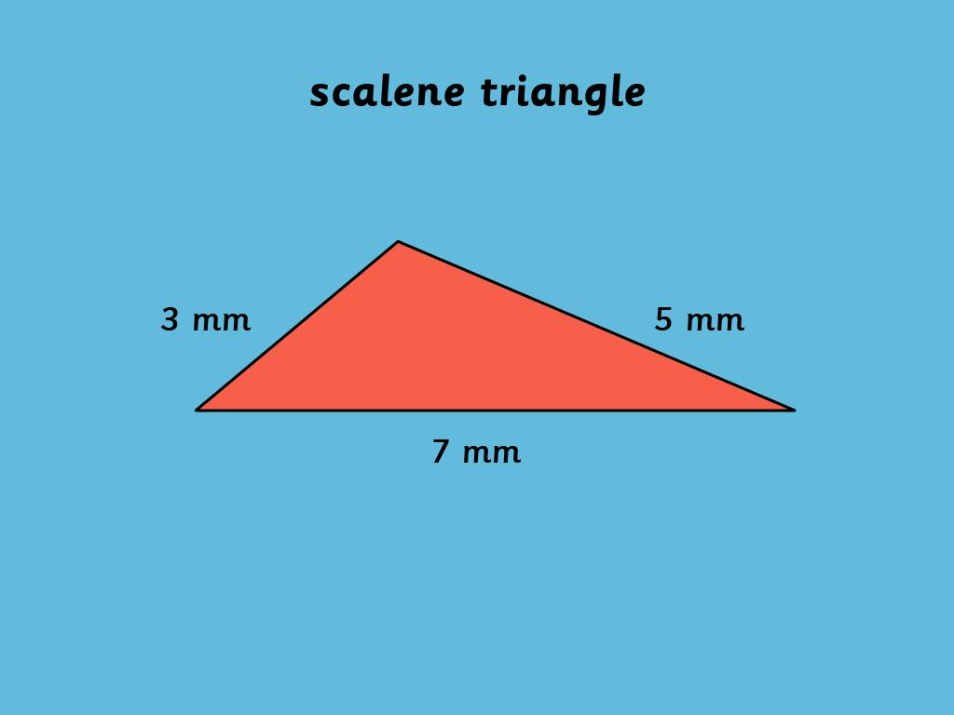
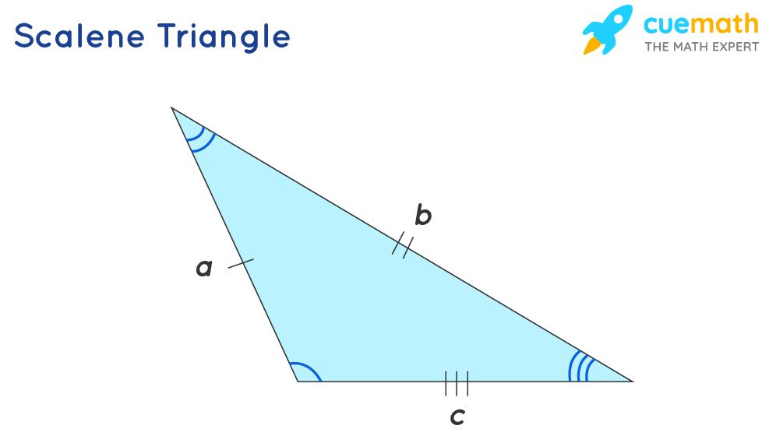
Properties
- No equal sides
- No equal angles
- Generally has no line symmetry

Types of Triangles by Angles
# Source: AI Source: Provided by: [Data Path: Persons Table -> ID Column: 1, Name_En Column: Motasem Essam] -> From: [ChatGPT] on [7/25/2026]
Triangles can also be classified according to their interior angles.
The three main types are:
- Acute triangle
- Right triangle
- Obtuse triangle

1. Acute Triangle
# Source: AI Source: Provided by: [Data Path: Persons Table -> ID Column: 1, Name_En Column: Motasem Essam] -> From: [ChatGPT] on [7/25/2026]
An acute triangle has three angles less than:
$${90}^{∘}$$
Therefore:
$$\boxed{A<{90}^{∘}, B<{90}^{∘}, C<{90}^{∘}}$$
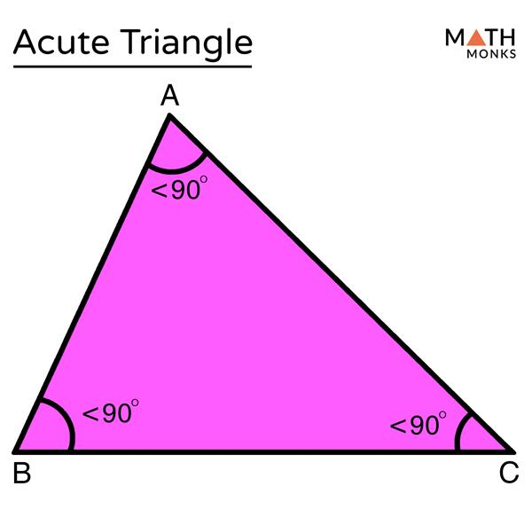
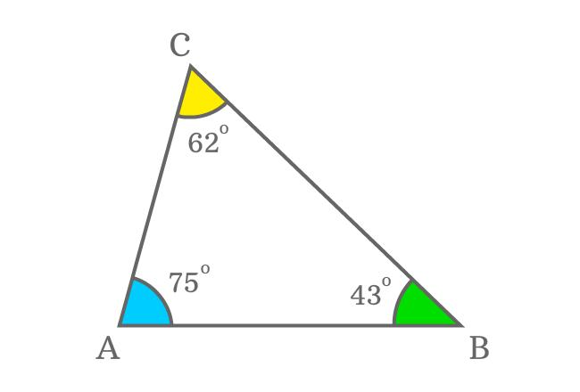
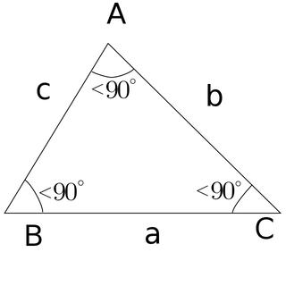
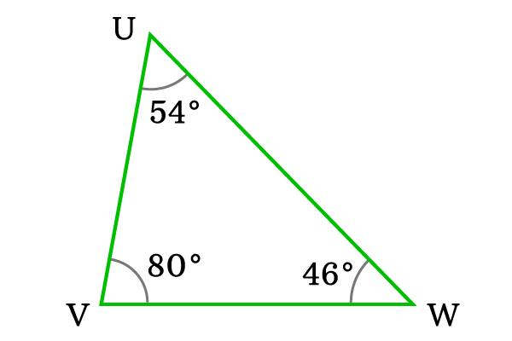
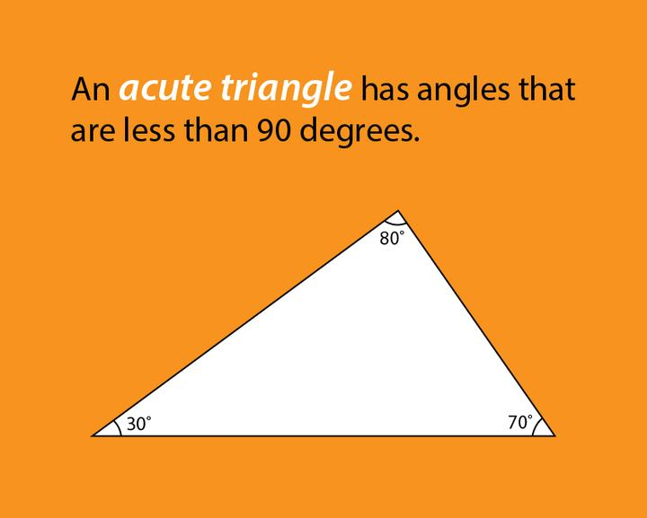
Example:
$${50}^{∘}+{60}^{∘}+{70}^{∘}={180}^{∘}$$

2. Right Triangle
# Source: AI Source: Provided by: [Data Path: Persons Table -> ID Column: 1, Name_En Column: Motasem Essam] -> From: [ChatGPT] on [7/25/2026]
A right triangle has exactly one right angle:
$$\boxed{{90}^{∘}}$$
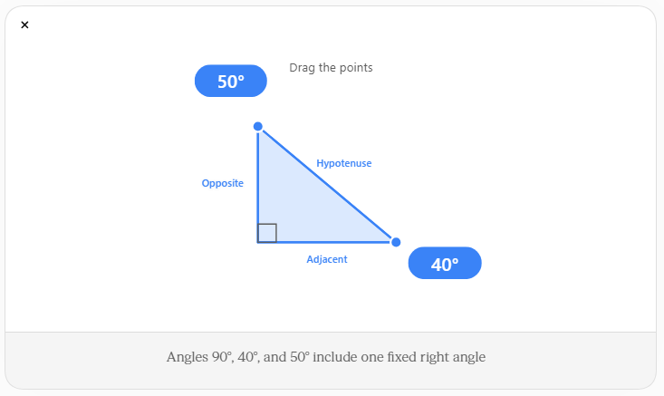
The side opposite the right angle is called the hypotenuse.
The other two sides are commonly called the legs.

Pythagorean Theorem
# Source: AI Source: Provided by: [Data Path: Persons Table -> ID Column: 1, Name_En Column: Motasem Essam] -> From: [ChatGPT] on [7/25/2026]
For a right triangle:
$$\boxed{a^{2}+b^{2}=c^{2}}$$
where:
- $a$and $b$are the legs.
- $c$is the hypotenuse.
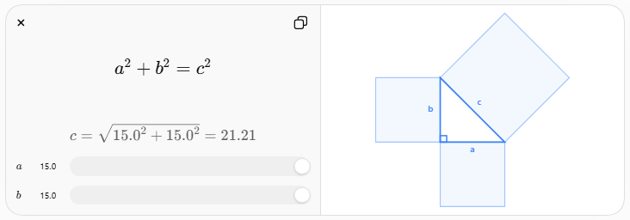
Example:
$$a=3, b=4$$
Then:
$$c^{2}=3^{2}+4^{2} \\ c^{2}=9+16 \\ c=5$$
Therefore:
$$\boxed{c=5}$$

3. Obtuse Triangle
# Source: AI Source: Provided by: [Data Path: Persons Table -> ID Column: 1, Name_En Column: Motasem Essam] -> From: [ChatGPT] on [7/25/2026]
An obtuse triangle has one angle greater than:
$${90}^{∘}$$
but less than:
$${180}^{∘}$$
Therefore:
$$\boxed{{90}^{∘}<A<{180}^{∘}}$$
for the obtuse angle.
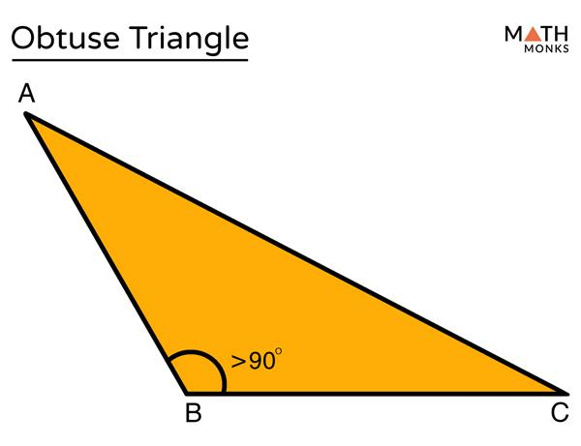
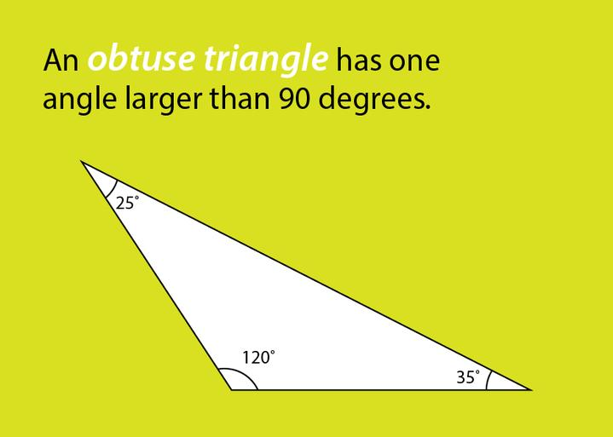
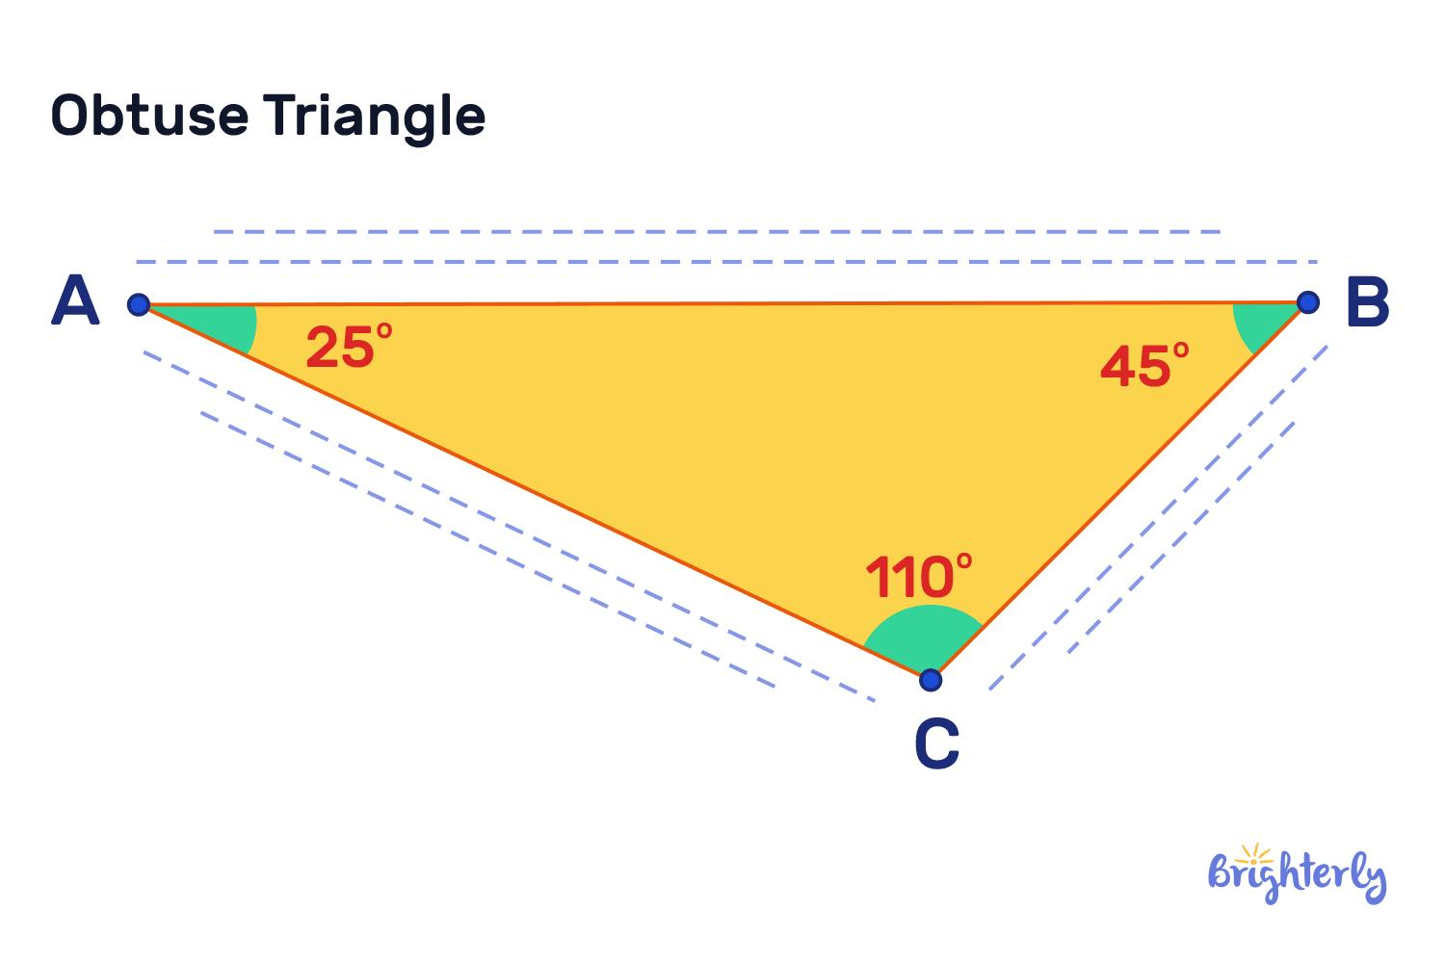
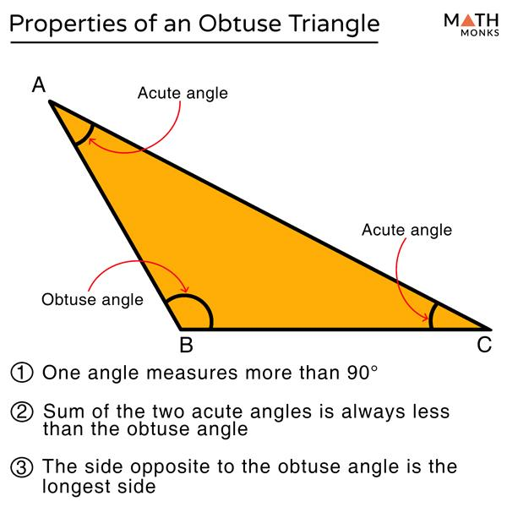
A triangle can have only one obtuse angle.

Classification by Sides and Angles

Definition
# Source: AI Source: Provided by: [Data Path: Persons Table -> ID Column: 1, Name_En Column: Motasem Essam] -> From: [ChatGPT] on [7/25/2026]
A triangle can be classified using both systems at the same time:
- Classification by sides — based on the number of equal side lengths.
- Classification by angles — based on the measures of its interior angles.
Therefore, a single triangle can have one side-based classification and one angle-based classification.
For example, a triangle can be:
$$\boxed{\text{Isosceles Right Triangle}}$$
This means it has:
- Two equal sides.
- One right angle measuring ${90}^{∘}$.
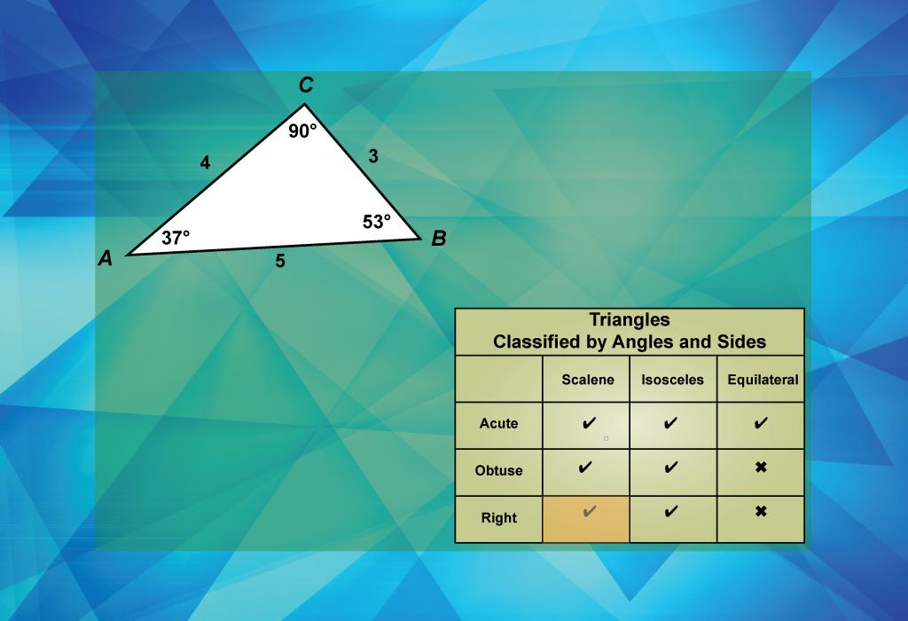
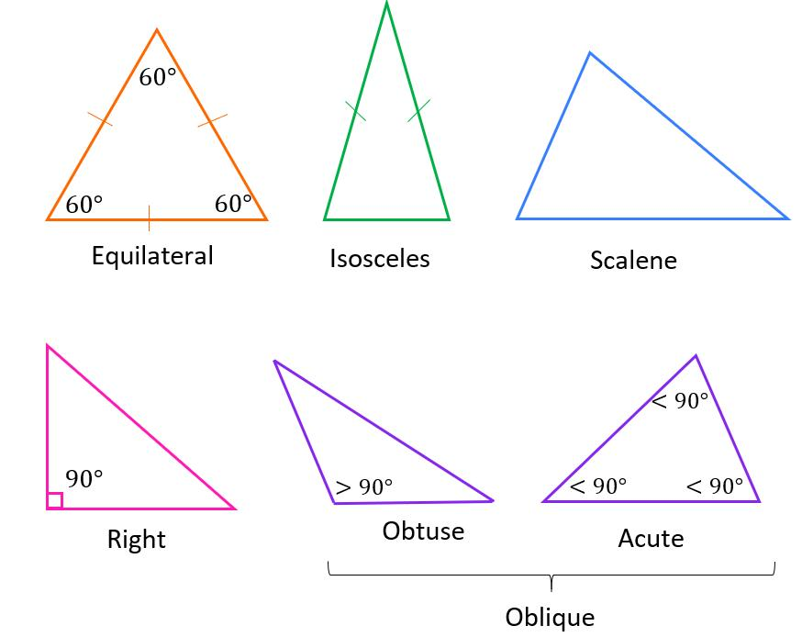
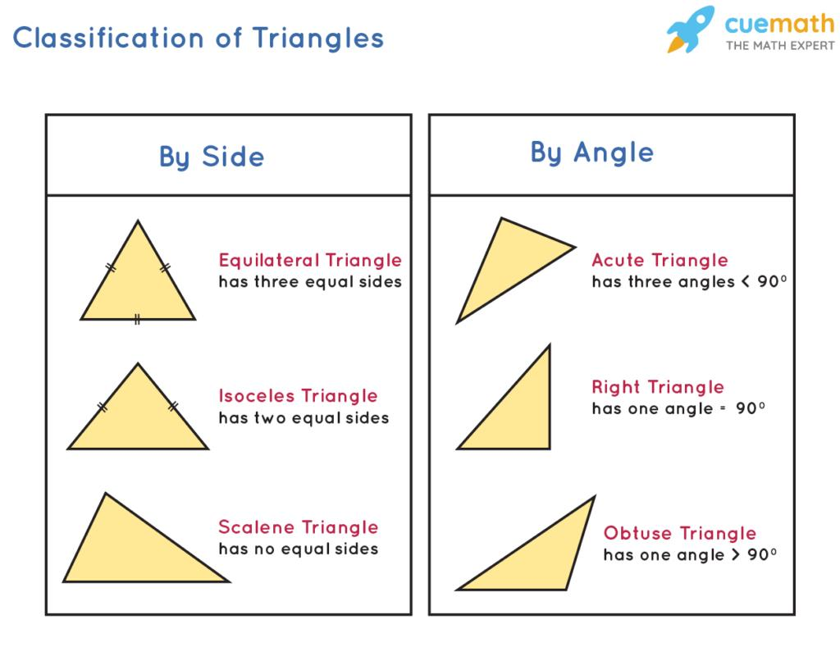
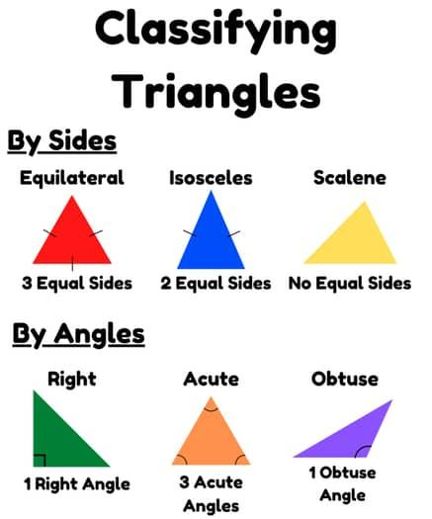
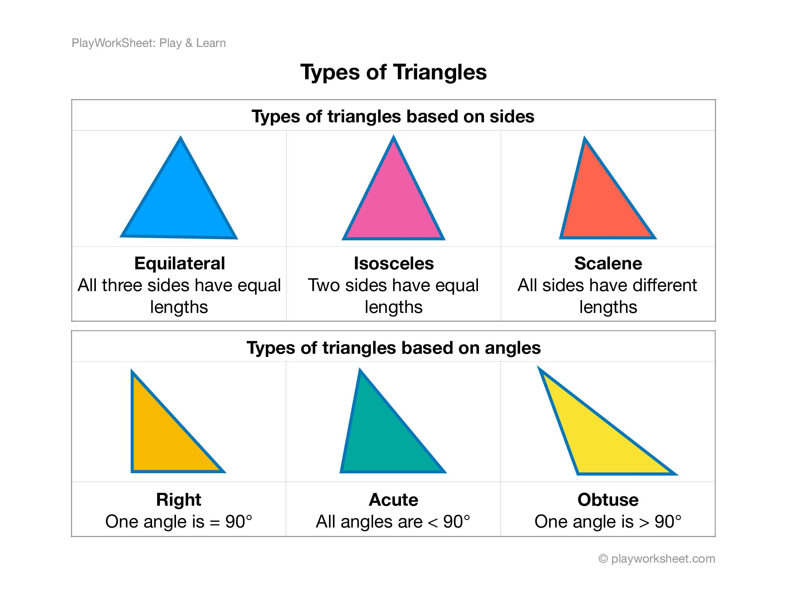
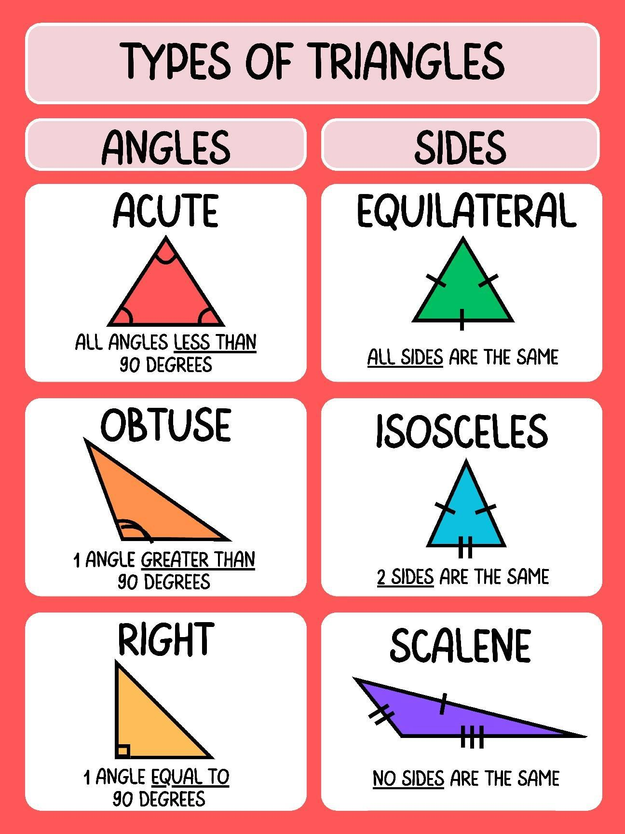
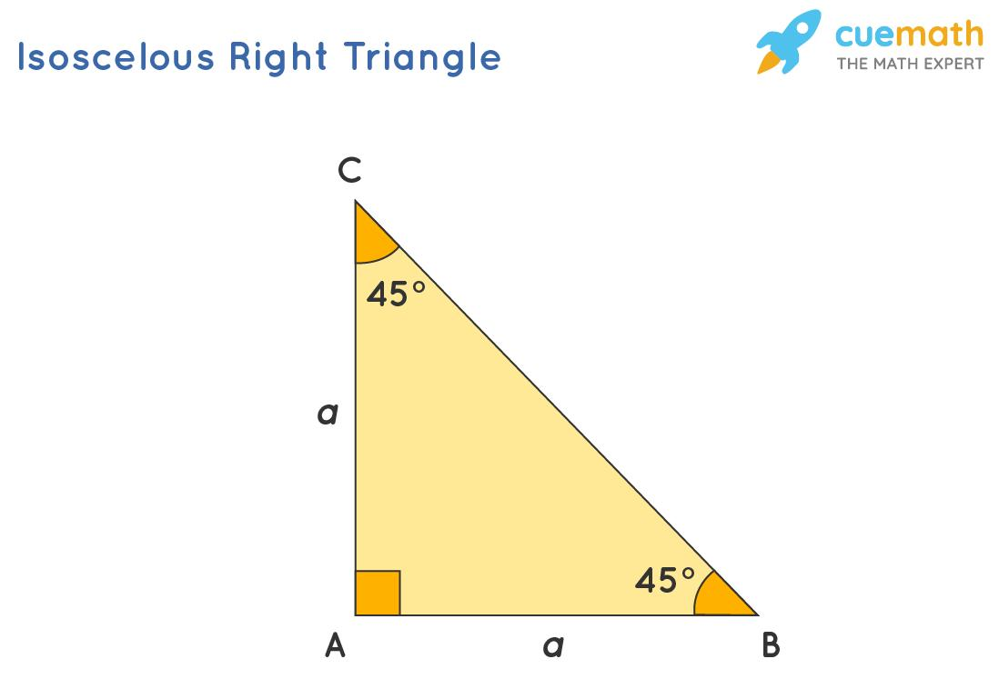
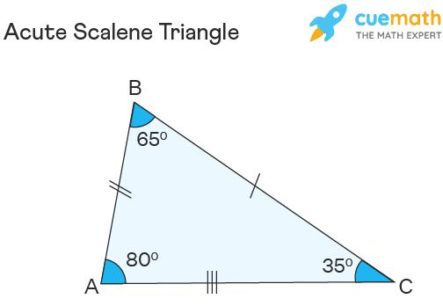
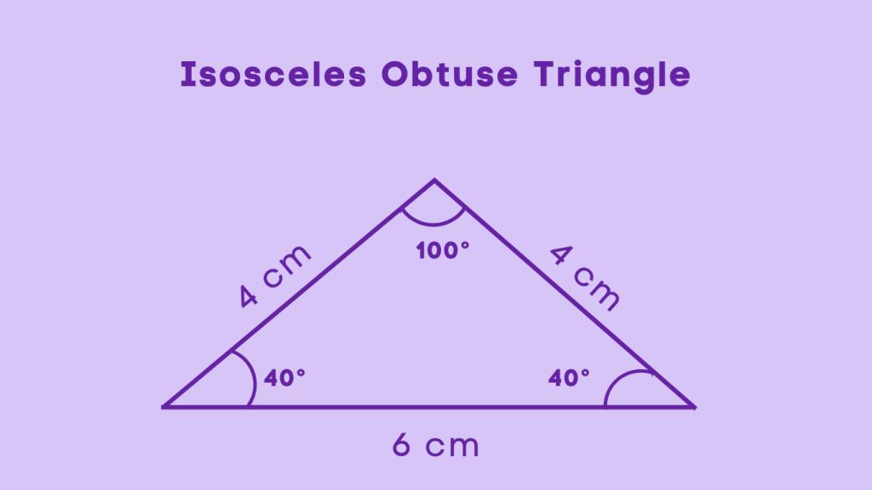

Classification by Sides
# Source: AI Source: Provided by: [Data Path: Persons Table -> ID Column: 1, Name_En Column: Motasem Essam] -> From: [ChatGPT] on [7/25/2026]
There are three main classifications by sides:
Equilateral
Three equal sides:
$$\boxed{a=b=c}$$
Isosceles
At least two equal sides:
$$\boxed{a=b}$$
Scalene
Three different side lengths:
$$\boxed{a≠b≠c}$$

Classification by Angles
# Source: AI Source: Provided by: [Data Path: Persons Table -> ID Column: 1, Name_En Column: Motasem Essam] -> From: [ChatGPT] on [7/25/2026]
There are three main classifications by angles:
Acute
All three angles are less than ${90}^{∘}$:
$$\boxed{A,B,C<{90}^{∘}}$$
Right
Exactly one angle is ${90}^{∘}$:
$$\boxed{A={90}^{∘}}$$
Obtuse
Exactly one angle is greater than ${90}^{∘}$:
$$\boxed{{90}^{∘}<A<{180}^{∘}}$$

Combined Classification
# Source: AI Source: Provided by: [Data Path: Persons Table -> ID Column: 1, Name_En Column: Motasem Essam] -> From: [ChatGPT] on [7/25/2026]
When both systems are used, the classification becomes more specific.
For example:
$$\boxed{\text{Scalene Acute Triangle}}$$
means:
- All three sides are different.
- All three angles are acute.
Another example:
$$\boxed{\text{Isosceles Right Triangle}}$$
means:
- Two sides are equal.
- One angle is ${90}^{∘}$.

Possible Combinations
# Source: AI Source: Provided by: [Data Path: Persons Table -> ID Column: 1, Name_En Column: Motasem Essam] -> From: [ChatGPT] on [7/25/2026]
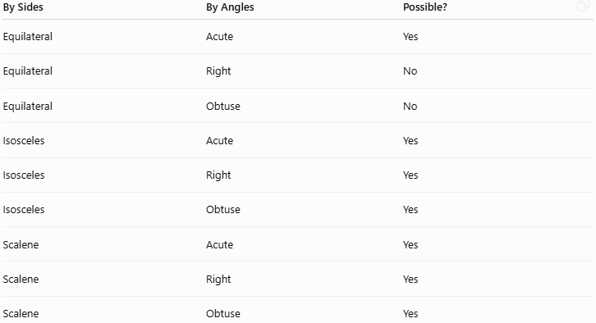
By Sides | By Angles | Possible?
Equilateral | Acute | Yes
Equilateral | Right | No
Equilateral | Obtuse | No
Isosceles | Acute | Yes
Isosceles | Right | Yes
Isosceles | Obtuse | Yes
Scalene | Acute | Yes
Scalene | Right | Yes
Scalene | Obtuse | Yes
Important Note
An equilateral triangle is always acute because all three angles are:
$${60}^{∘}$$
Therefore, it cannot be a right or obtuse triangle.

Examples

Example 1 — Equilateral Acute
# Source: AI Source: Provided by: [Data Path: Persons Table -> ID Column: 1, Name_En Column: Motasem Essam] -> From: [ChatGPT] on [7/25/2026]
Side lengths:
$$5, 5, 5$$
Angles:
$${60}^{∘}, {60}^{∘}, {60}^{∘}$$
Classification:
$$\boxed{\text{Equilateral Acute Triangle}}$$

Example 2 — Isosceles Right
# Source: AI Source: Provided by: [Data Path: Persons Table -> ID Column: 1, Name_En Column: Motasem Essam] -> From: [ChatGPT] on [7/25/2026]
Side lengths:
$$5, 5, 5\sqrt{2}$$
Angles:
$${45}^{∘}, {45}^{∘}, {90}^{∘}$$
Classification:
$$\boxed{\text{Isosceles Right Triangle}}$$
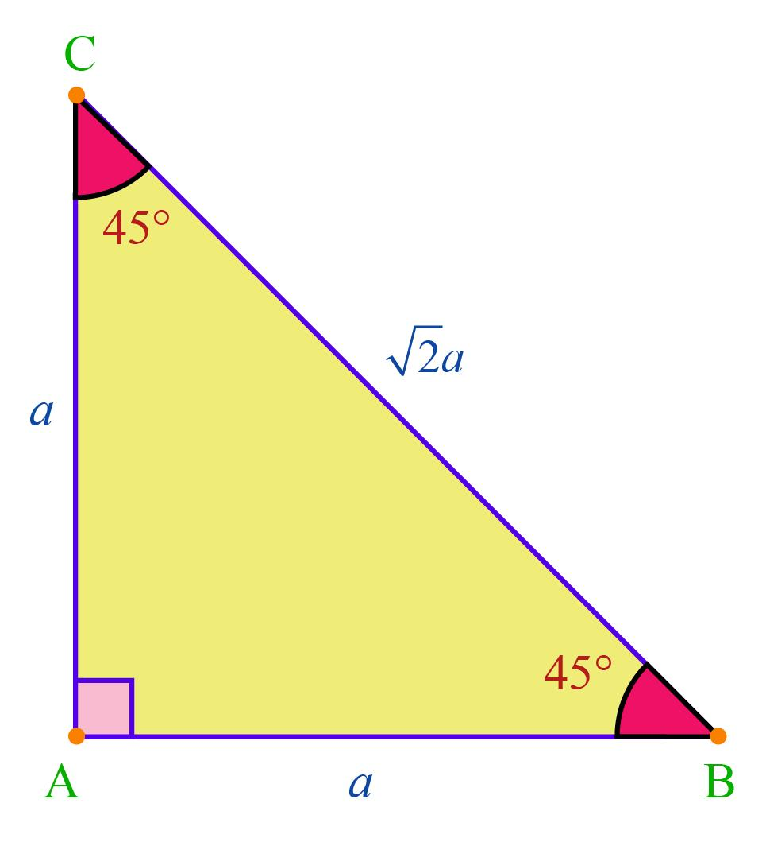
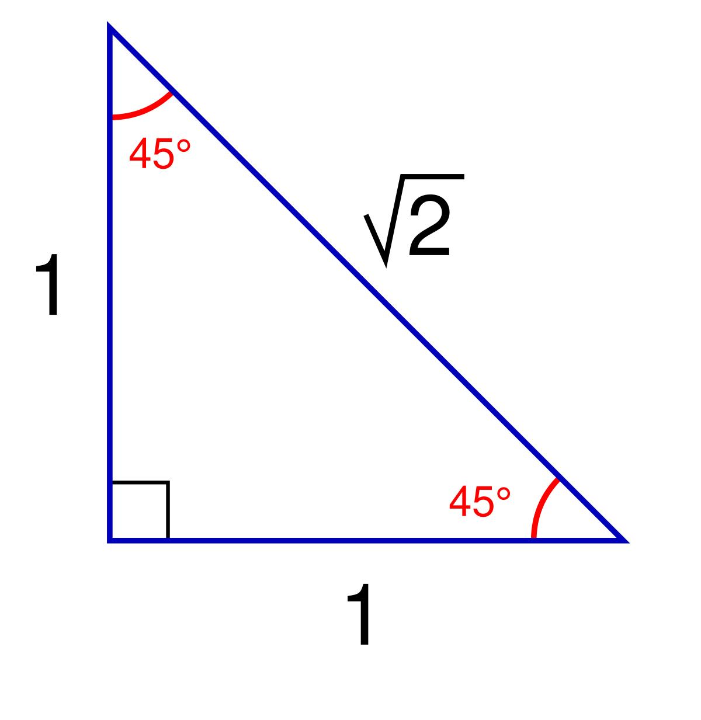
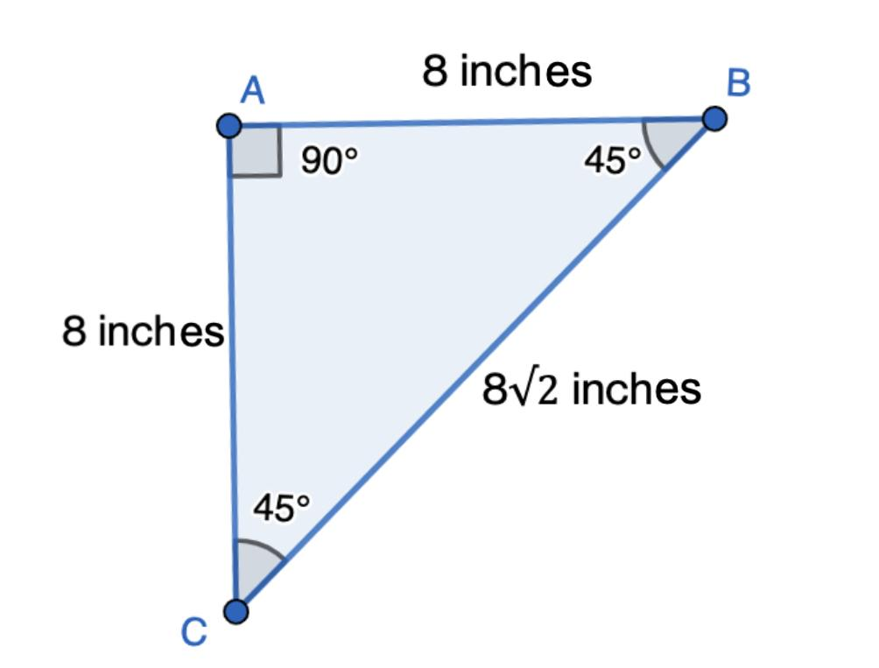
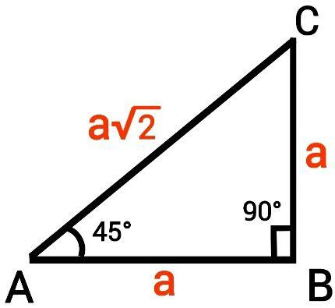

Example 3 — Scalene Right
# Source: AI Source: Provided by: [Data Path: Persons Table -> ID Column: 1, Name_En Column: Motasem Essam] -> From: [ChatGPT] on [7/25/2026]
Side lengths:
$$3, 4, 5$$
Angles:
$${90}^{∘}, {53.13}^{∘}, {36.87}^{∘}$$
Classification:
$$\boxed{\text{Scalene Right Triangle}}$$

Example 4 — Isosceles Obtuse
# Source: AI Source: Provided by: [Data Path: Persons Table -> ID Column: 1, Name_En Column: Motasem Essam] -> From: [ChatGPT] on [7/25/2026]
Angles:
$${40}^{∘}, {40}^{∘}, {100}^{∘}$$
Two angles are equal, so the triangle is isosceles.
One angle is greater than ${90}^{∘}$, so it is obtuse.
Classification:
$$\boxed{\text{Isosceles Obtuse Triangle}}$$

Example 5 — Scalene Acute
# Source: AI Source: Provided by: [Data Path: Persons Table -> ID Column: 1, Name_En Column: Motasem Essam] -> From: [ChatGPT] on [7/25/2026]
Angles:
$${50}^{∘}, {60}^{∘}, {70}^{∘}$$
All three angles are less than ${90}^{∘}$, and they are all different.
Classification:
$$\boxed{\text{Scalene Acute Triangle}}$$

Classification Matrix
# Source: AI Source: Provided by: [Data Path: Persons Table -> ID Column: 1, Name_En Column: Motasem Essam] -> From: [ChatGPT] on [7/25/2026]
The complete relationship can be summarized as:
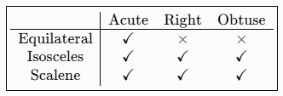
$$\boxed{\begin{matrix} & \text{Acute} & \text{Right} & \text{Obtuse} \\ \text{Equilateral} & ✓ & × & × \\ \text{Isosceles} & ✓ & ✓ & ✓ \\ \text{Scalene} & ✓ & ✓ & ✓\end{matrix}}$$
Thus, there are seven possible combined classifications:
- Equilateral Acute
- Isosceles Acute
- Isosceles Right
- Isosceles Obtuse
- Scalene Acute
- Scalene Right
- Scalene Obtuse

Perimeter of a Triangle
# Source: AI Source: Provided by: [Data Path: Persons Table -> ID Column: 1, Name_En Column: Motasem Essam] -> From: [ChatGPT] on [7/25/2026]
The perimeter is the total length of the three sides.
If the side lengths are:
$$a, b, c$$
then:
$$\boxed{P=a+b+c}$$
Example
If:
$$a=5, b=6, c=7$$
then:
$$P=5+6+7 \\ \boxed{P=18}$$

Area of a Triangle
# Source: AI Source: Provided by: [Data Path: Persons Table -> ID Column: 1, Name_En Column: Motasem Essam] -> From: [ChatGPT] on [7/25/2026]
The area of a triangle is:
$$\boxed{A=\frac{1}{2}bh}$$
where:
- $b$= base
- $h$= perpendicular height
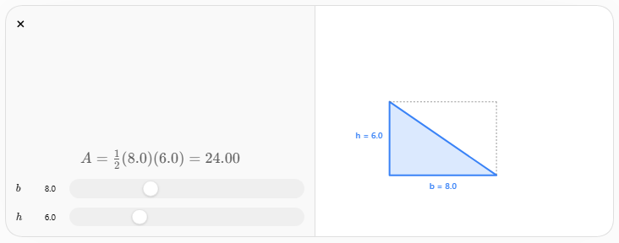
Example
If:
$$b=10$$
and:
$$h=6$$
then:
$$A=\frac{1}{2}\left(10\right)\left(6\right) \\ \boxed{A=30}$$

Base and Height
# Source: AI Source: Provided by: [Data Path: Persons Table -> ID Column: 1, Name_En Column: Motasem Essam] -> From: [ChatGPT] on [7/25/2026]
The base can be any side of the triangle.
The height is the perpendicular distance from the opposite vertex to the line containing the base.
Therefore:
$$\boxed{h⊥b}$$
The height does not necessarily have to lie completely inside the triangle, especially for an obtuse triangle.
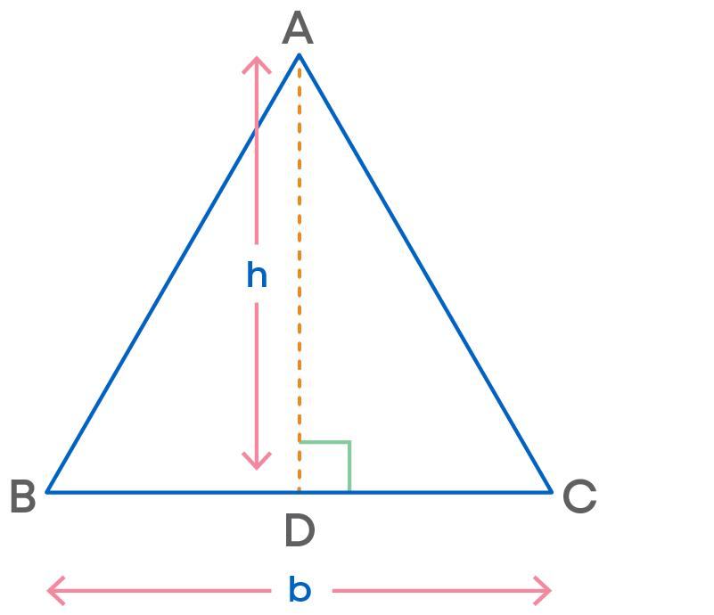
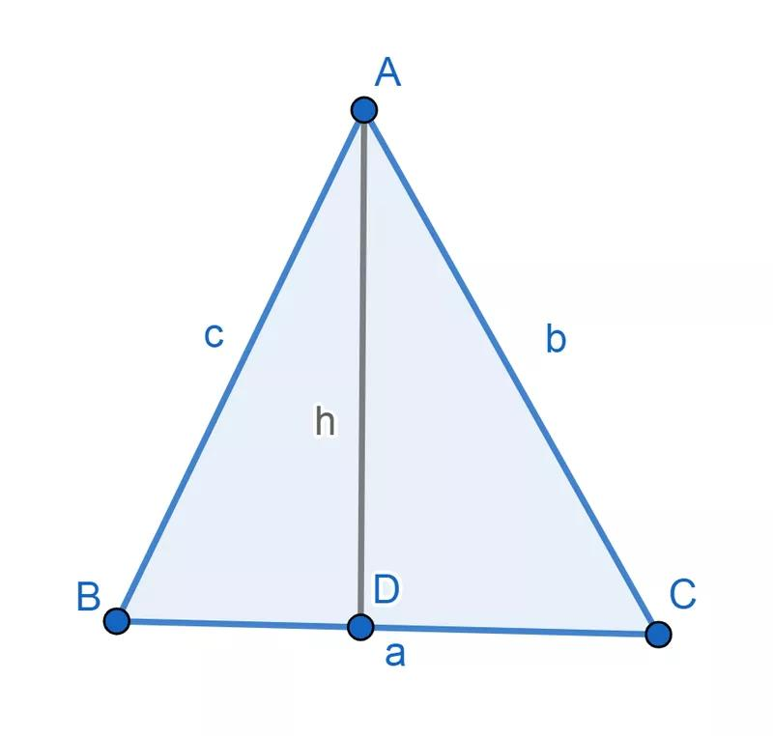
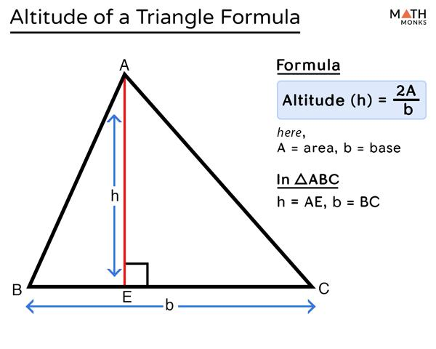
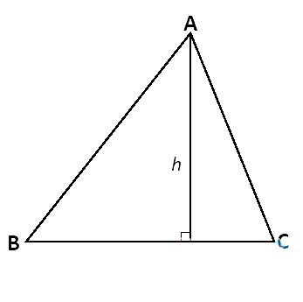

Altitude
# Source: AI Source: Provided by: [Data Path: Persons Table -> ID Column: 1, Name_En Column: Motasem Essam] -> From: [ChatGPT] on [7/25/2026]
An altitude is a perpendicular segment from a vertex to the opposite side or its extension.
Every triangle has three altitudes.
The three altitudes intersect at a point called the:
$$\boxed{\text{Orthocenter}}$$
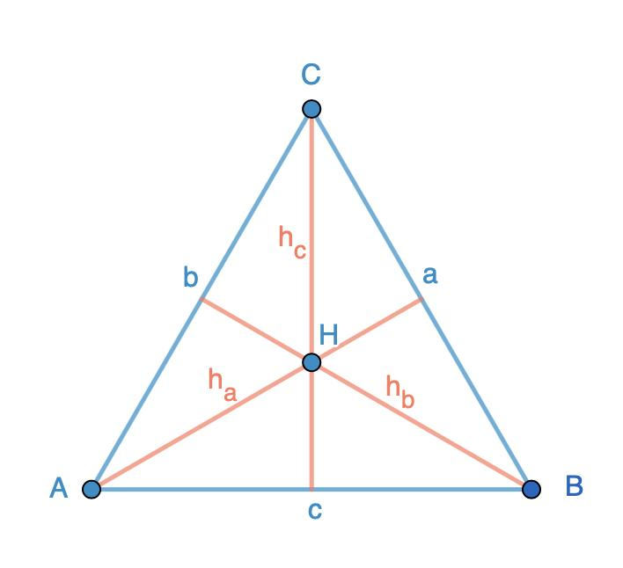
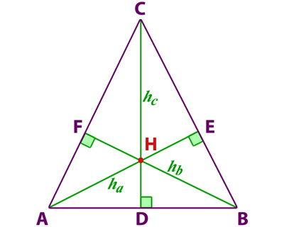
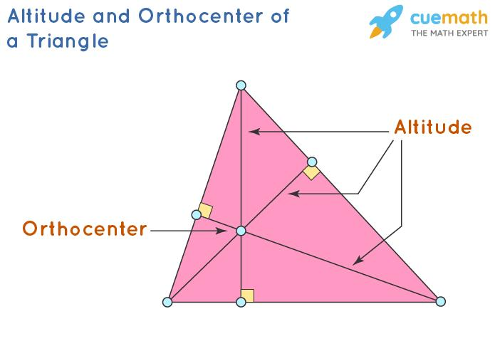
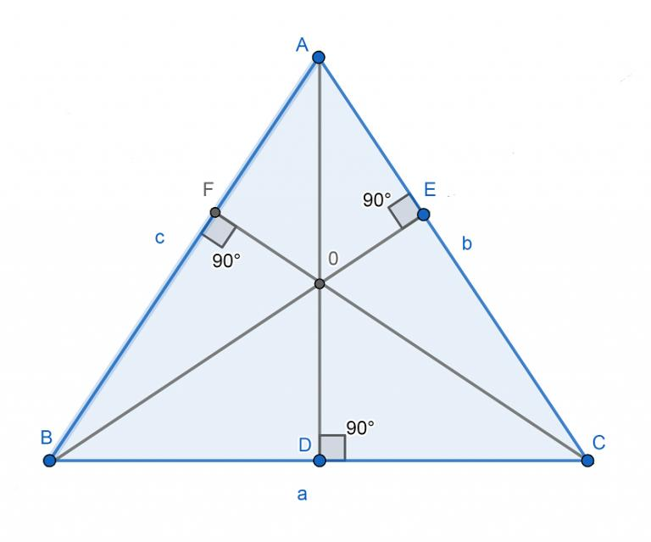

Median
# Source: AI Source: Provided by: [Data Path: Persons Table -> ID Column: 1, Name_En Column: Motasem Essam] -> From: [ChatGPT] on [7/25/2026]
A median is a line segment connecting a vertex to the midpoint of the opposite side.
Every triangle has:
$$\boxed{3\text{ medians}}$$
The three medians intersect at the:
$$\boxed{\text{Centroid}}$$
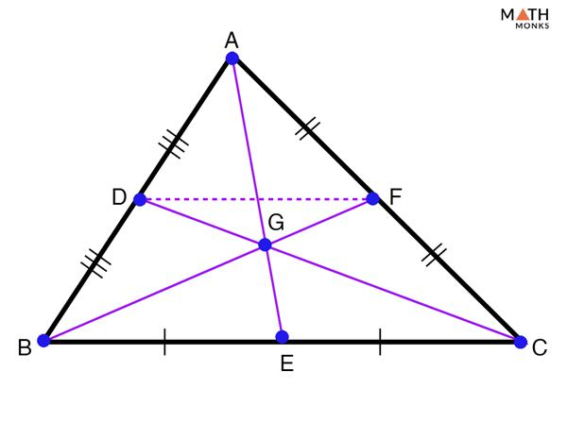
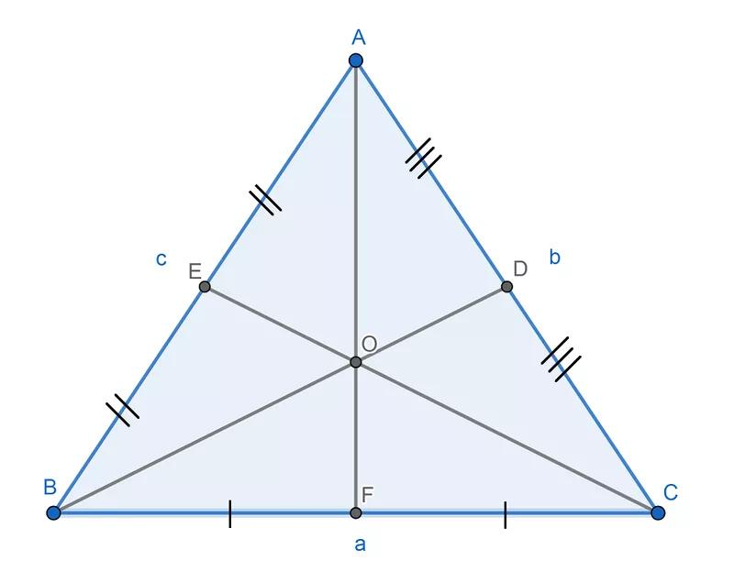
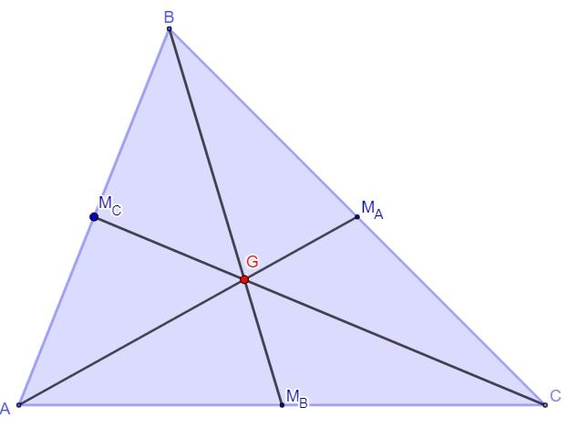
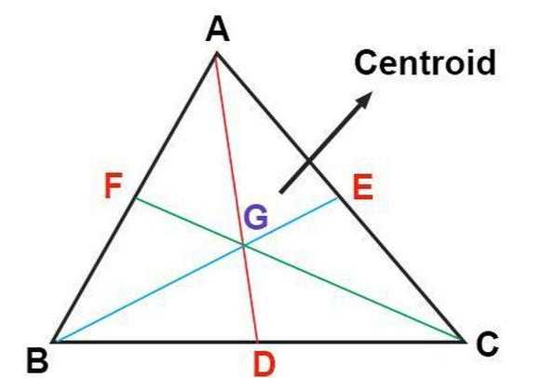
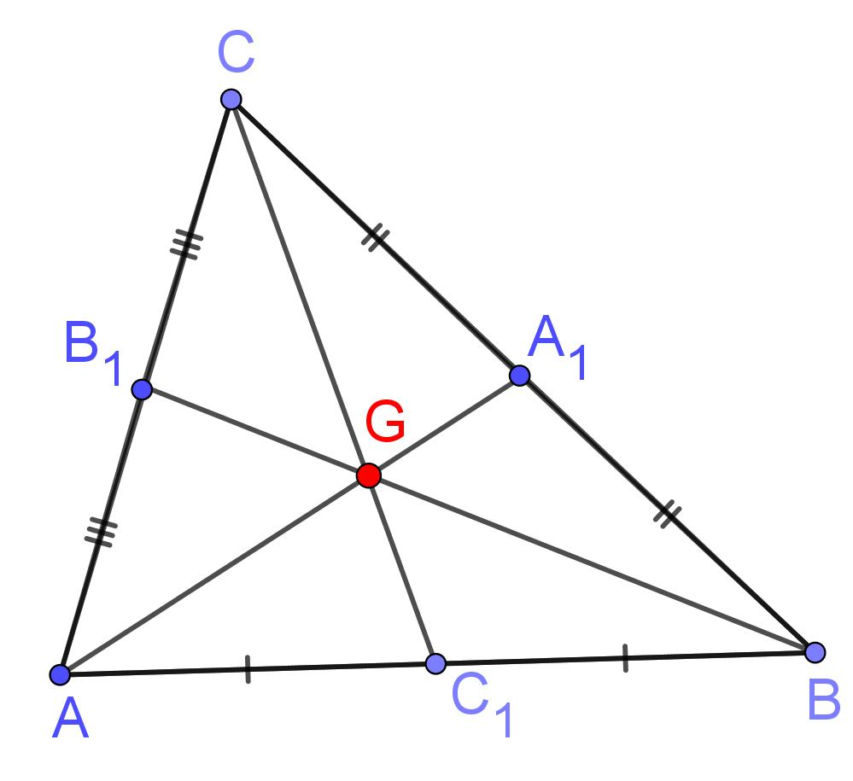

Angle Bisector
# Source: AI Source: Provided by: [Data Path: Persons Table -> ID Column: 1, Name_En Column: Motasem Essam] -> From: [ChatGPT] on [7/25/2026]
An angle bisector divides an angle into two equal angles.
For example:
$$∠BAC={60}^{∘}$$
If the angle is bisected:
$$∠BAD=∠DAC={30}^{∘}$$
Every triangle has:
$$\boxed{3\text{ angle bisectors}}$$
The three internal angle bisectors intersect at the:
$$\boxed{\text{Incenter}}$$
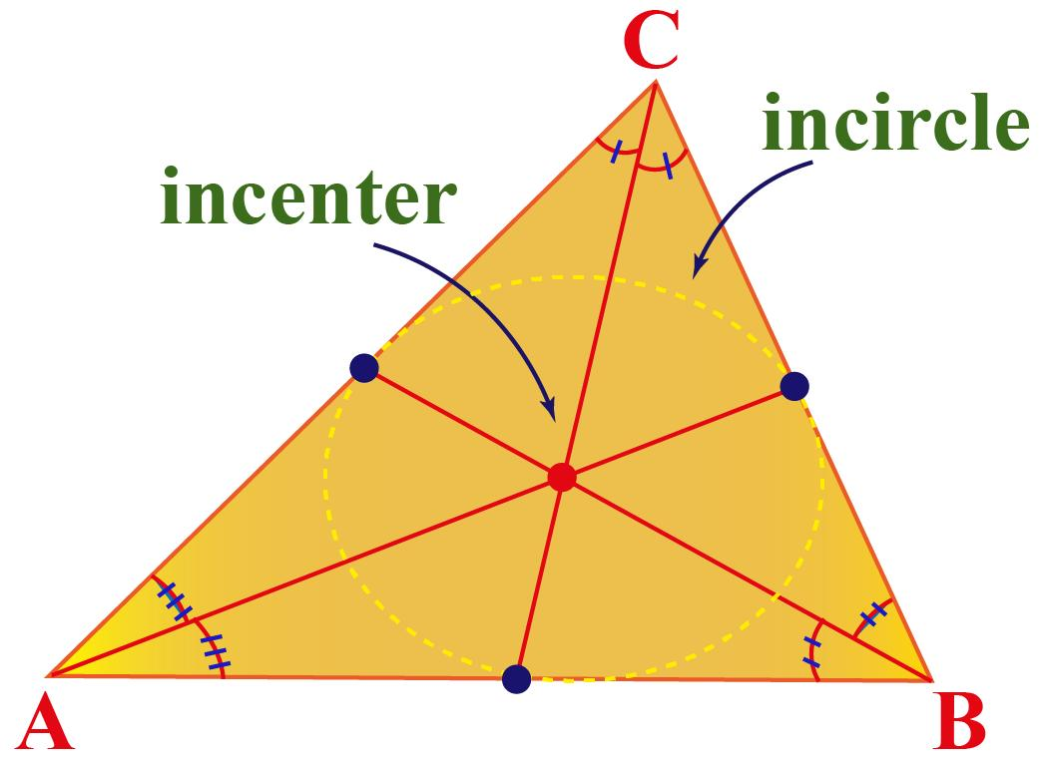
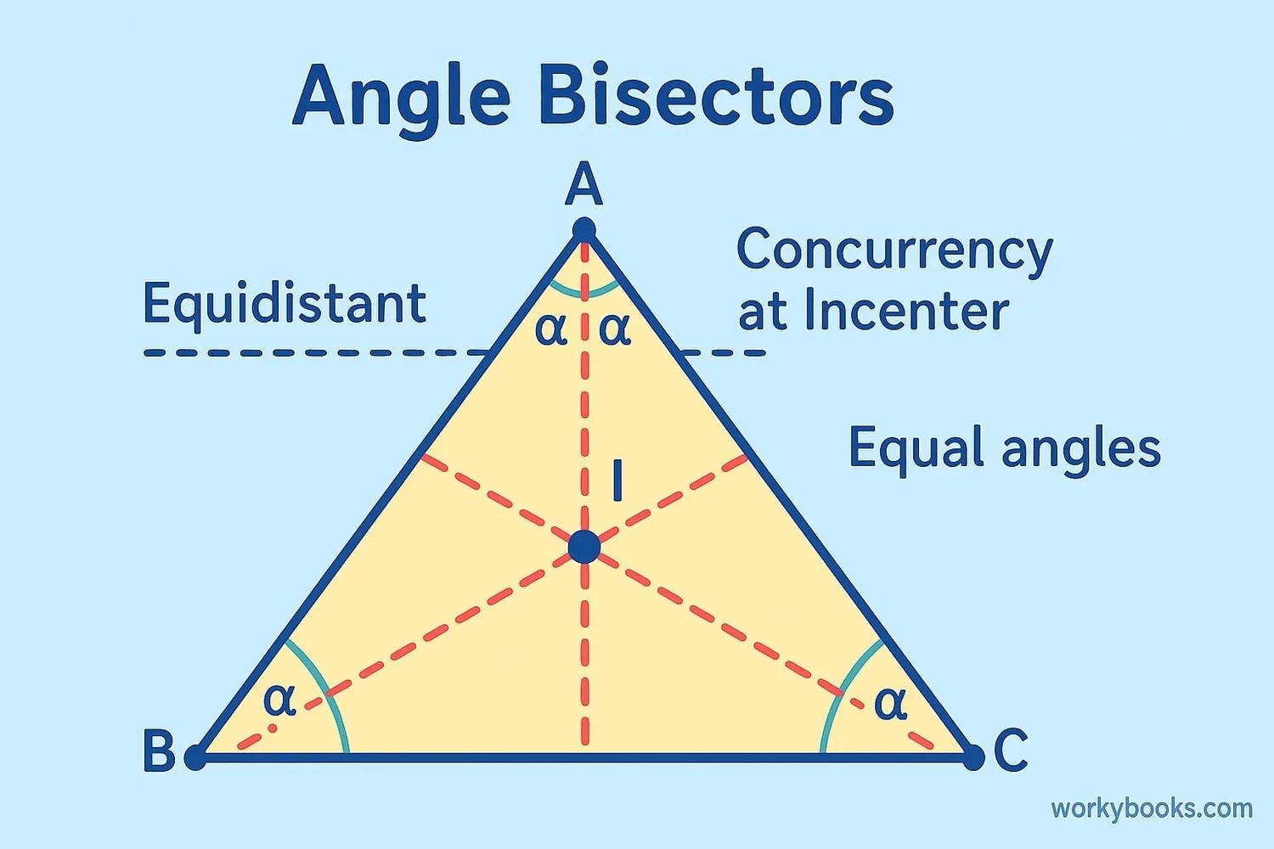
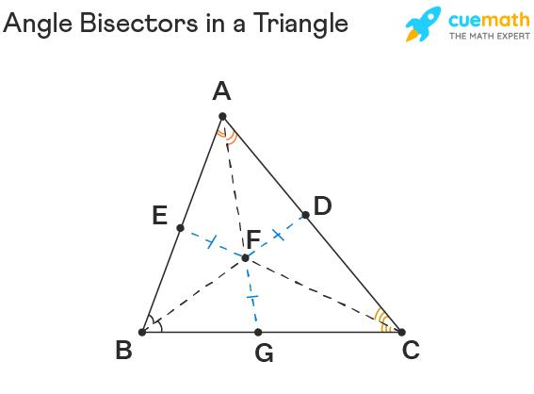
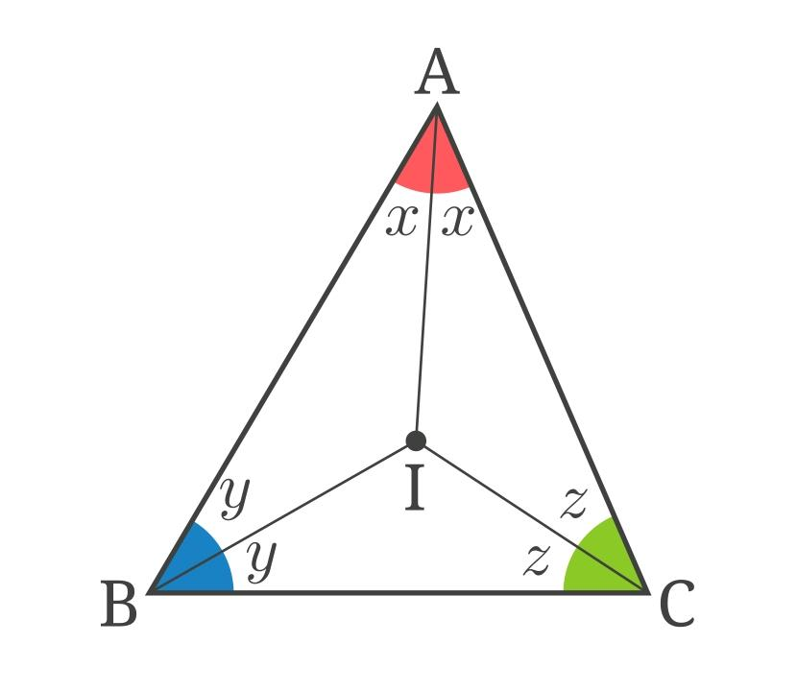
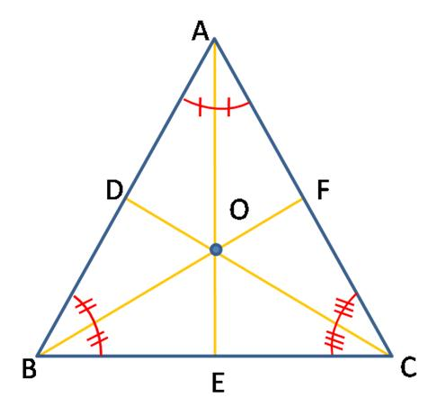

Perpendicular Bisector
# Source: AI Source: Provided by: [Data Path: Persons Table -> ID Column: 1, Name_En Column: Motasem Essam] -> From: [ChatGPT] on [7/25/2026]
A perpendicular bisector of a side passes through its midpoint and is perpendicular to that side.
Every triangle has three perpendicular bisectors.
They intersect at the:
$$\boxed{\text{Circumcenter}}$$
The circumcenter is the center of the triangle's circumcircle.
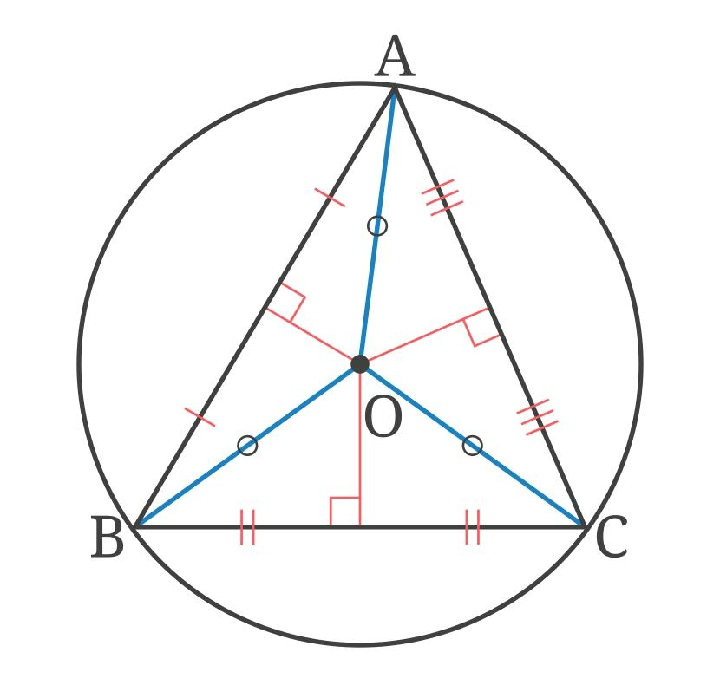
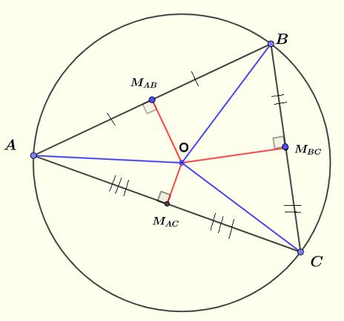
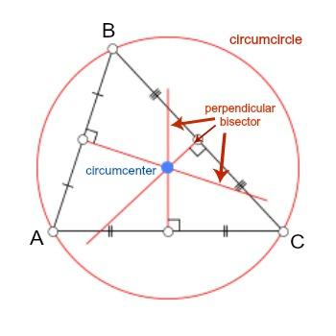
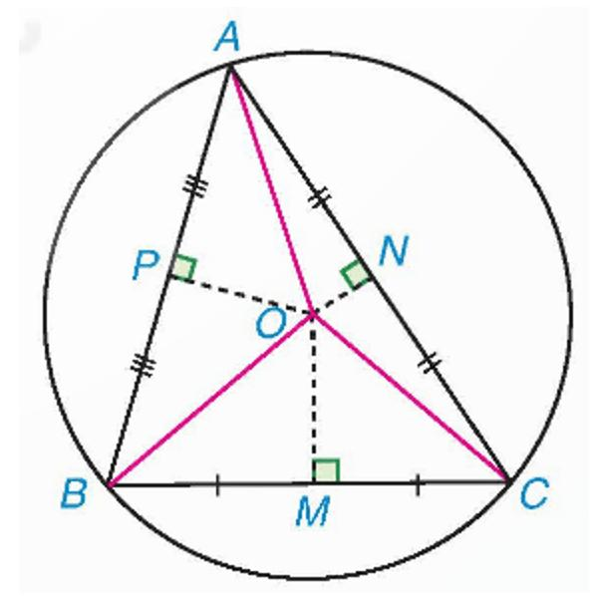
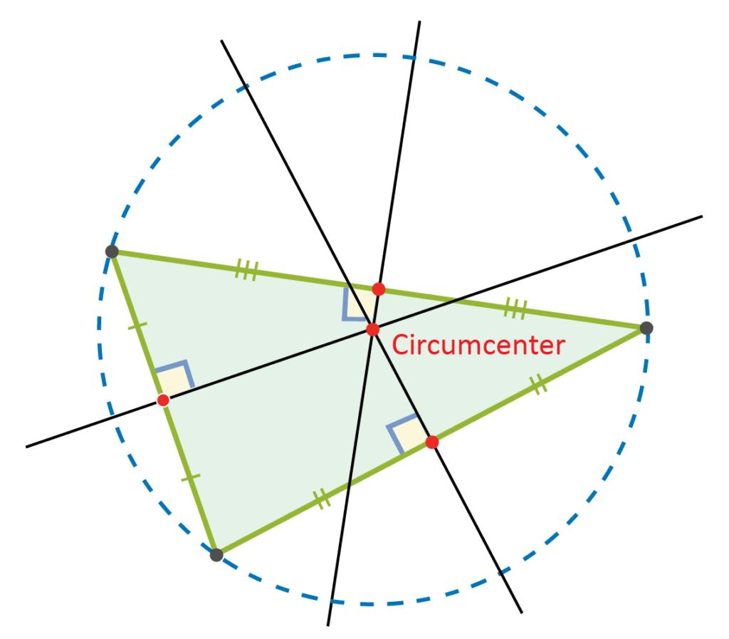
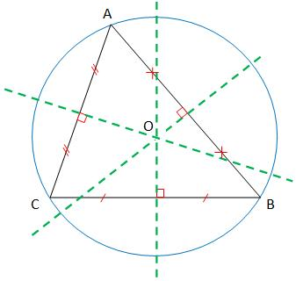

Important Triangle Centers
# Source: AI Source: Provided by: [Data Path: Persons Table -> ID Column: 1, Name_En Column: Motasem Essam] -> From: [ChatGPT] on [7/25/2026]
A triangle has several important centers.
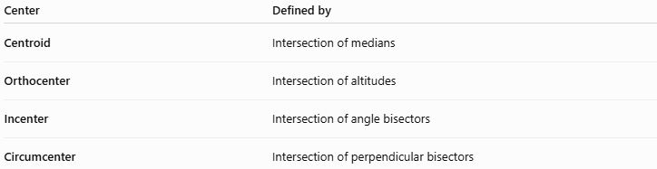
Center | Defined by
Centroid | Intersection of medians
Orthocenter | Intersection of altitudes
Incenter | Intersection of angle bisectors
Circumcenter | Intersection of perpendicular bisectors
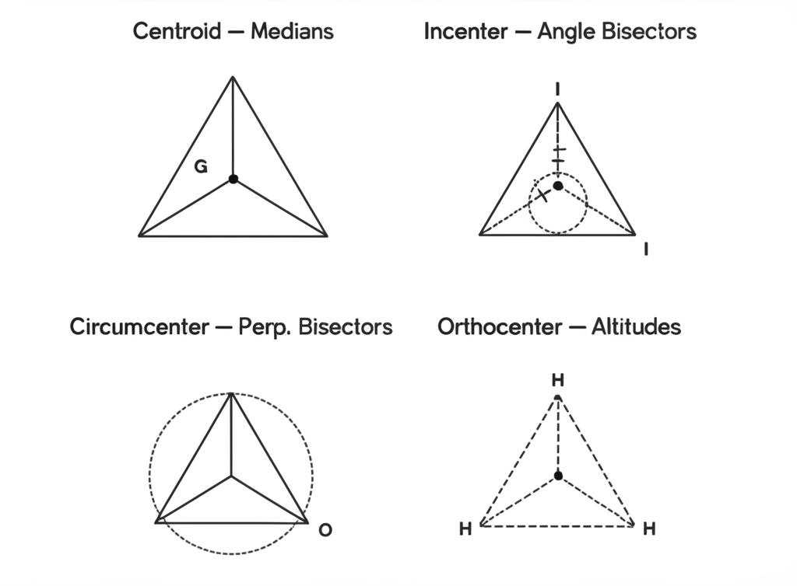
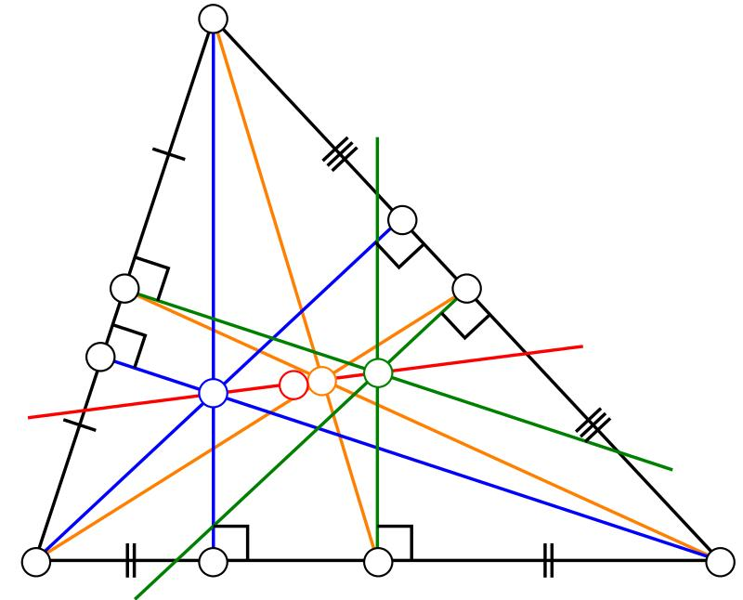
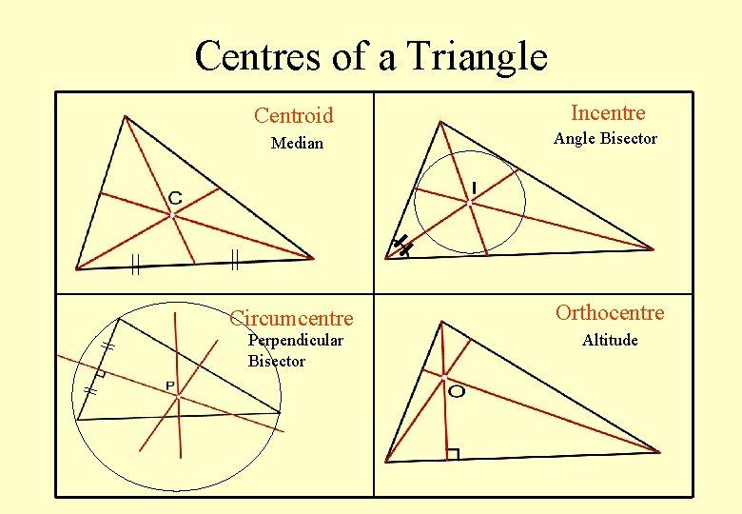
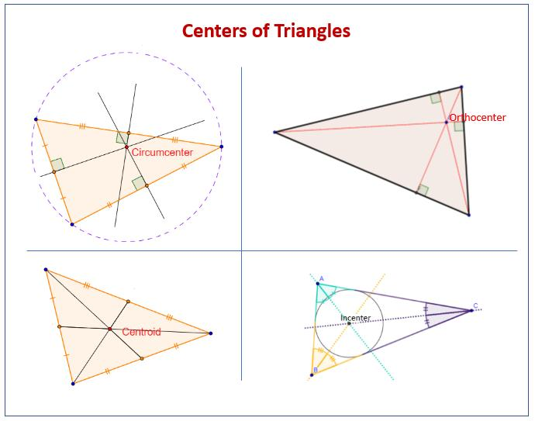

Interior Angles
# Source: AI Source: Provided by: [Data Path: Persons Table -> ID Column: 1, Name_En Column: Motasem Essam] -> From: [ChatGPT] on [7/25/2026]
The interior angles of a triangle always satisfy:
$$\boxed{A+B+C={180}^{∘}}$$
This property applies to:
- Equilateral triangles
- Isosceles triangles
- Scalene triangles
- Acute triangles
- Right triangles
- Obtuse triangles

Exterior Angles
# Source: AI Source: Provided by: [Data Path: Persons Table -> ID Column: 1, Name_En Column: Motasem Essam] -> From: [ChatGPT] on [7/25/2026]
An exterior angle is formed by extending one side of a triangle.
An exterior angle equals the sum of the two opposite interior angles.
$$\boxed{\text{Exterior Angle}=A+B}$$
where $A$and $B$are the two remote interior angles.
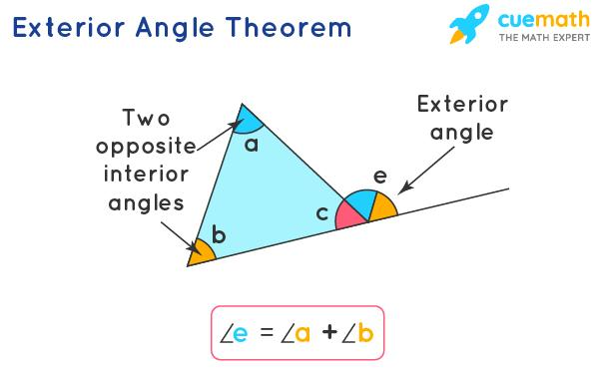
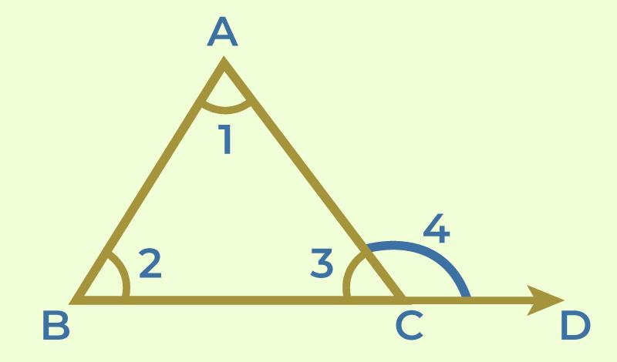
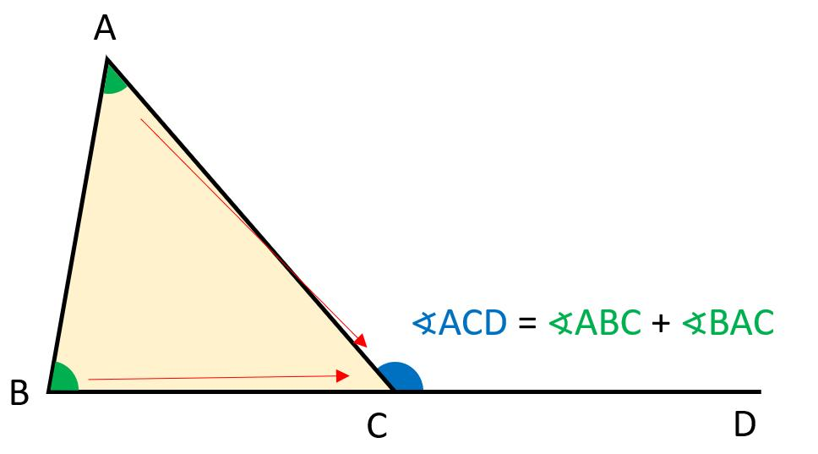
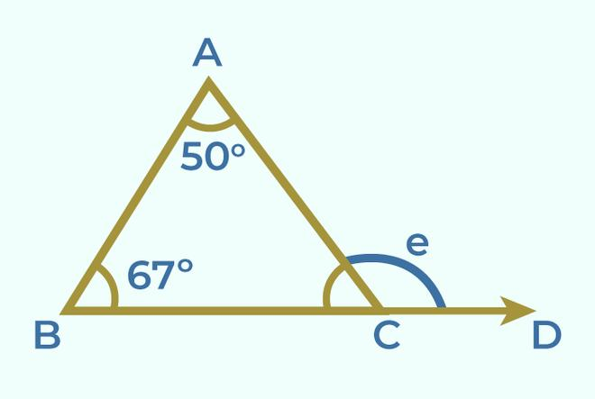
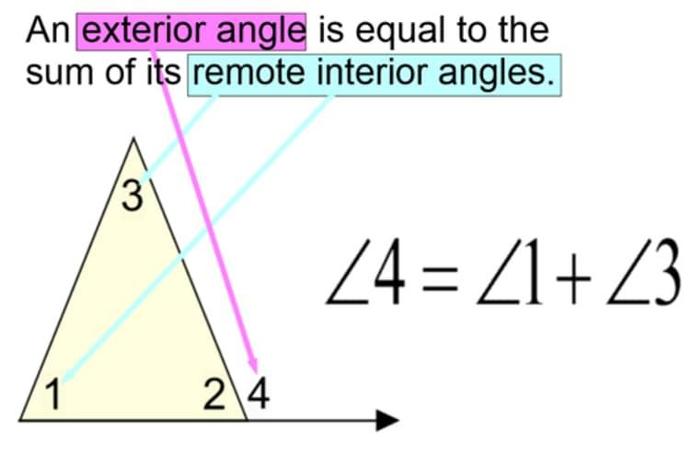

Triangle Inequality
# Source: AI Source: Provided by: [Data Path: Persons Table -> ID Column: 1, Name_En Column: Motasem Essam] -> From: [ChatGPT] on [7/25/2026]
The side lengths of a triangle must satisfy the triangle inequality.
For sides $a,b,c$:
$$\boxed{a+b>c} \\ \boxed{a+c>b} \\ \boxed{b+c>a}$$
In words:
The sum of any two sides must be greater than the third side.
Example
Can $3,4,5$ form a triangle?
$$3+4>5 \\ 7>5$$
Yes.
Therefore:
$$\boxed{3,4,5\text{ can form a triangle}}$$

Relationship Between Sides and Angles
# Source: AI Source: Provided by: [Data Path: Persons Table -> ID Column: 1, Name_En Column: Motasem Essam] -> From: [ChatGPT] on [7/25/2026]
In a triangle:
The largest angle is opposite the longest side.
And:
The smallest angle is opposite the shortest side.
For example, if:
$$a>b>c$$
then the opposite angles satisfy:
$$\boxed{A>B>C}$$

Congruent Triangles
# Source: AI Source: Provided by: [Data Path: Persons Table -> ID Column: 1, Name_En Column: Motasem Essam] -> From: [ChatGPT] on [7/25/2026]
Two triangles are congruent when they have the same shape and the same size.
Common congruence criteria include:
- SSS
- SAS
- ASA
- AAS
- RHS/HL for right triangles
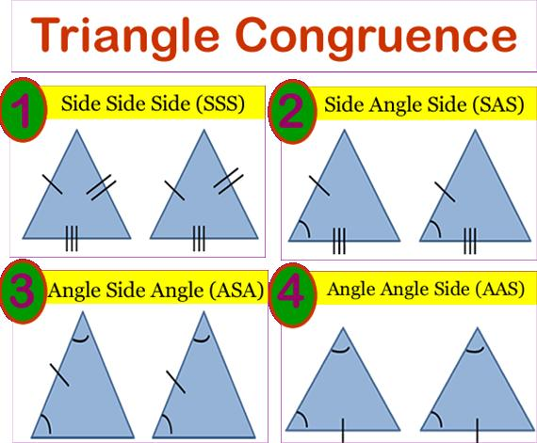
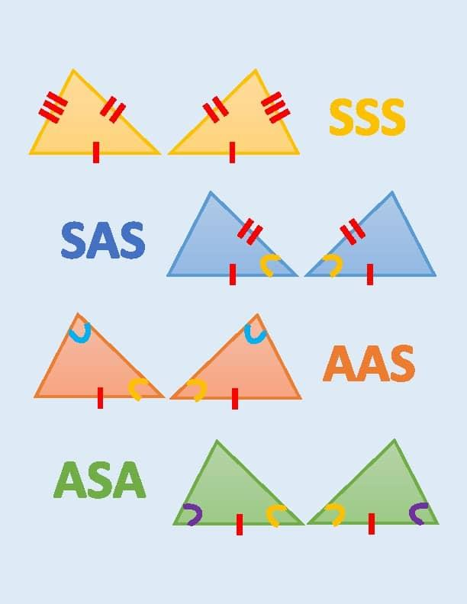
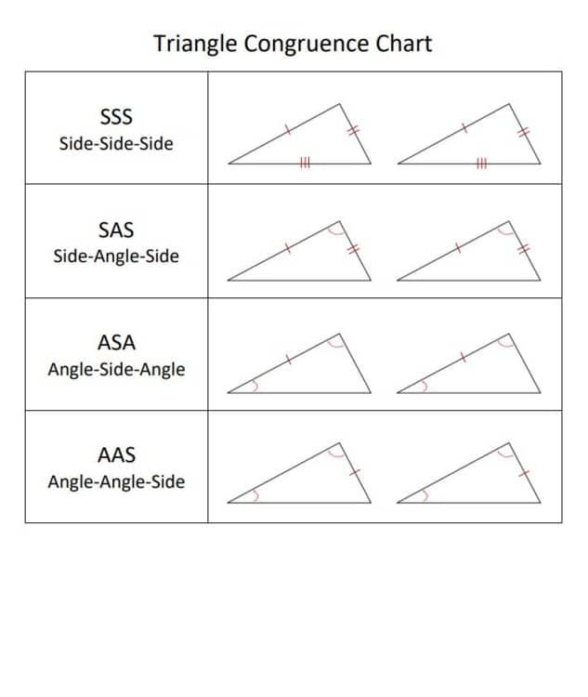

Similar Triangles
# Source: AI Source: Provided by: [Data Path: Persons Table -> ID Column: 1, Name_En Column: Motasem Essam] -> From: [ChatGPT] on [7/25/2026]
Two triangles are similar when they have the same shape but may have different sizes.
Corresponding angles are equal and corresponding sides are proportional.
Common similarity criteria include:
- AA
- SAS similarity
- SSS similarity
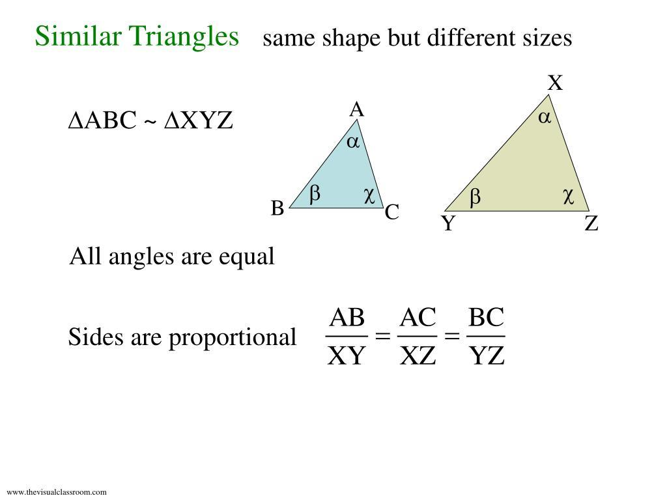
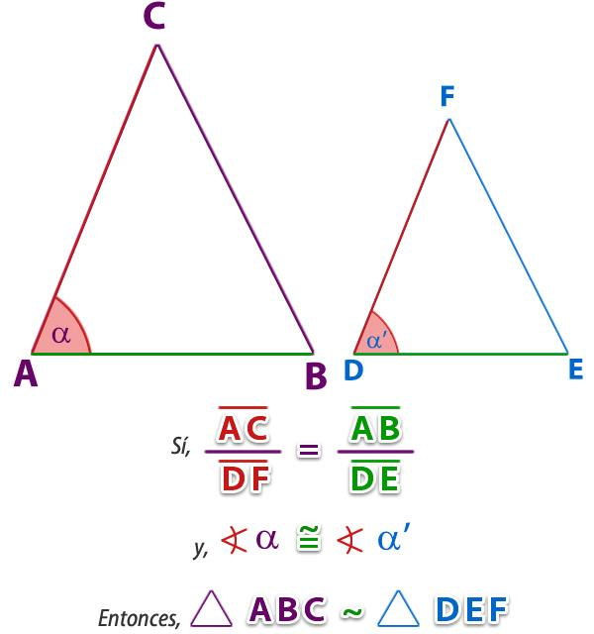
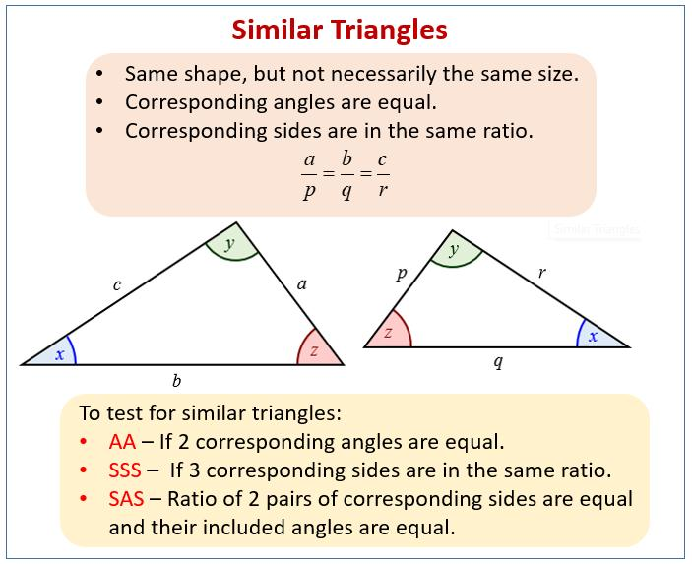
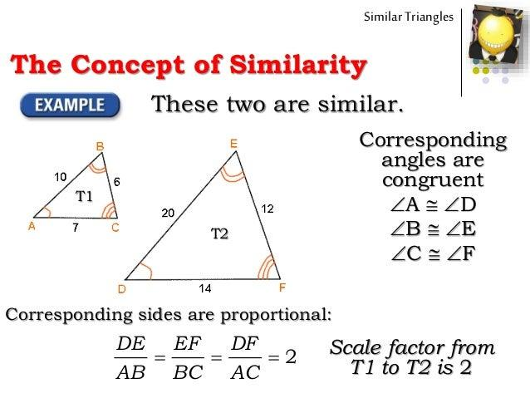
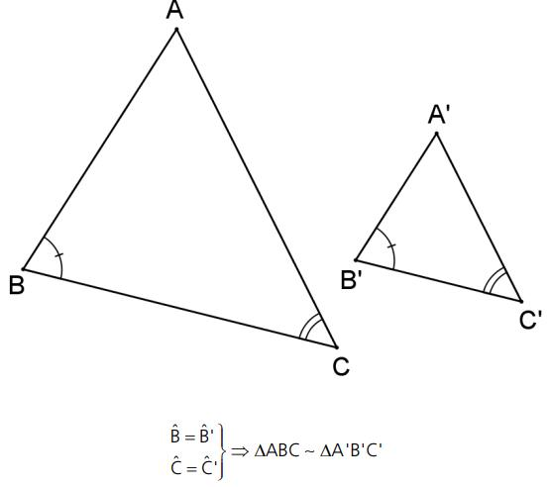

Triangle Symmetry
# Source: AI Source: Provided by: [Data Path: Persons Table -> ID Column: 1, Name_En Column: Motasem Essam] -> From: [ChatGPT] on [7/25/2026]
Different triangles have different symmetry properties.
Equilateral Triangle
Has:
$$\boxed{3}$$
lines of symmetry.
Isosceles Triangle
Has:
$$\boxed{1}$$
line of symmetry in the non-equilateral case.
Scalene Triangle
Has:
$$\boxed{0}$$
lines of symmetry.

Triangle Transformations
# Source: AI Source: Provided by: [Data Path: Persons Table -> ID Column: 1, Name_En Column: Motasem Essam] -> From: [ChatGPT] on [7/25/2026]
Triangles can undergo geometric transformations such as:
- Translation
- Rotation
- Reflection
- Dilation
- Shear
For example, a triangle can be reflected across the $x$-axis:
$$\boxed{\left(x , y\right)→\left(x , -y\right)}$$
or dilated about the origin:
$$\boxed{\left(x , y\right)→\left(kx , ky\right)}$$

Triangle in Coordinate Geometry
# Source: AI Source: Provided by: [Data Path: Persons Table -> ID Column: 1, Name_En Column: Motasem Essam] -> From: [ChatGPT] on [7/25/2026]
A triangle can be represented using coordinates.
For example:
$$A=\left(x_{1} , y_{1}\right) \\ B=\left(x_{2} , y_{2}\right) \\ C=\left(x_{3} , y_{3}\right)$$
The distance between two vertices can be calculated using:
$$\boxed{d=\sqrt{{\left(x_{2}-x_{1}\right)}^{2}+{\left(y_{2}-y_{1}\right)}^{2}}}$$
This allows the side lengths of a triangle to be determined from its coordinates.

Area Using Coordinates
# Source: AI Source: Provided by: [Data Path: Persons Table -> ID Column: 1, Name_En Column: Motasem Essam] -> From: [ChatGPT] on [7/25/2026]
For vertices:
$$A=\left(x_{1} , y_{1}\right) \\ B=\left(x_{2} , y_{2}\right) \\ C=\left(x_{3} , y_{3}\right)$$
the area can be calculated using:
$$\boxed{A=\frac{1}{2}∣x_{1}\left(y_{2}-y_{3}\right)+x_{2}\left(y_{3}-y_{1}\right)+x_{3}\left(y_{1}-y_{2}\right)∣}$$
This is useful when the base and perpendicular height are not immediately known.

Special Triangle — 45°–45°–90°
# Source: AI Source: Provided by: [Data Path: Persons Table -> ID Column: 1, Name_En Column: Motasem Essam] -> From: [ChatGPT] on [7/25/2026]
A ${45}^{∘}$-${45}^{∘}$-${90}^{∘}$ triangle is an isosceles right triangle.
Its side ratio is:
$$\boxed{1:1:\sqrt{2}}$$
If each leg is $s$, then the hypotenuse is:
$$\boxed{s\sqrt{2}}$$
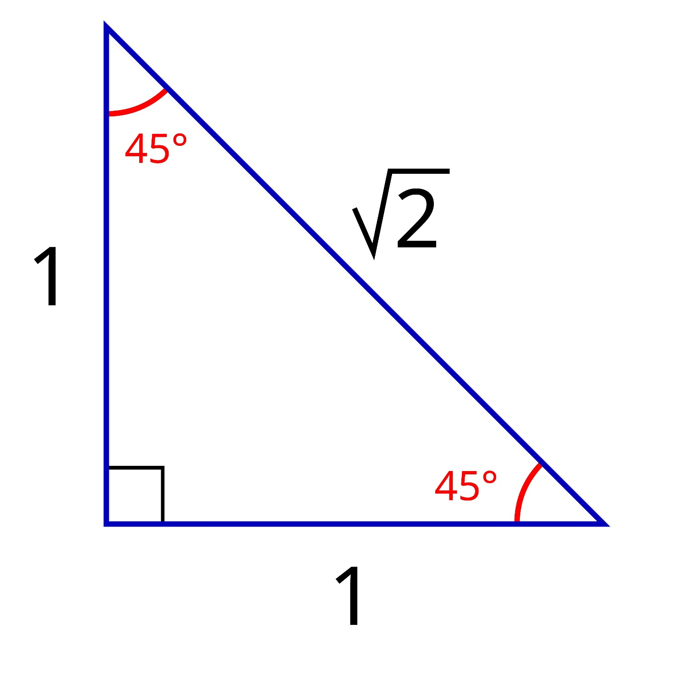
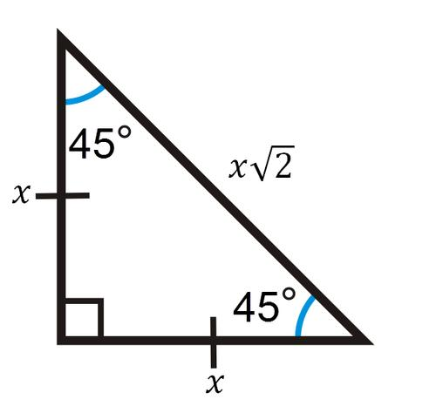
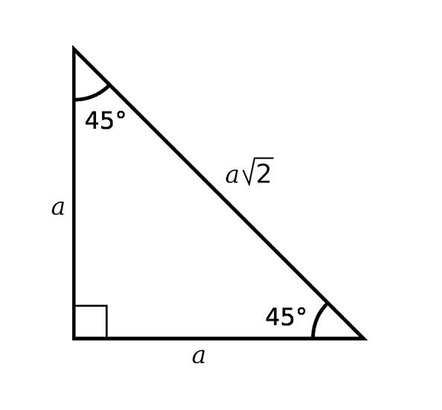
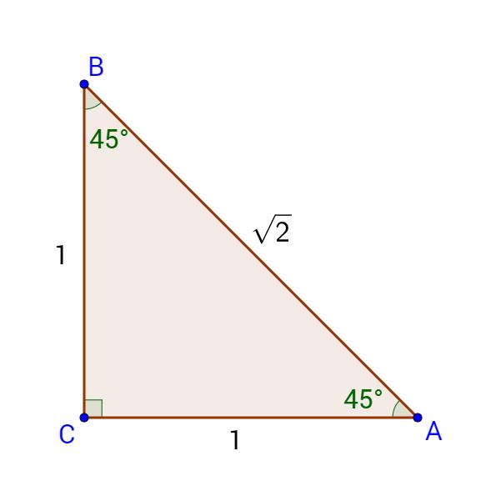

Special Triangle — 30°–60°–90°
# Source: AI Source: Provided by: [Data Path: Persons Table -> ID Column: 1, Name_En Column: Motasem Essam] -> From: [ChatGPT] on [7/25/2026]
A ${30}^{∘}$-${60}^{∘}$-${90}^{∘}$ triangle has side ratio:
$$\boxed{1:\sqrt{3}:2}$$
where:
- $1$= side opposite ${30}^{∘}$
- $\sqrt{3}$= side opposite ${60}^{∘}$
- $2$= hypotenuse
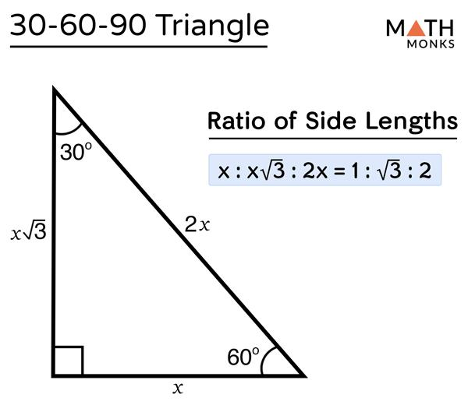
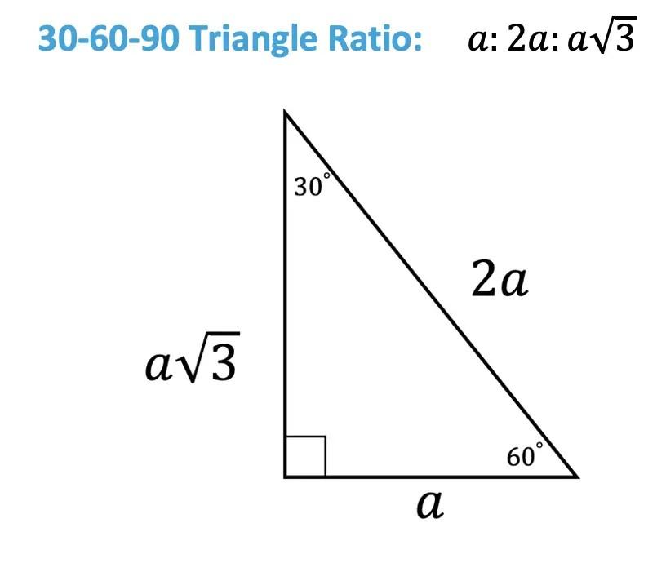
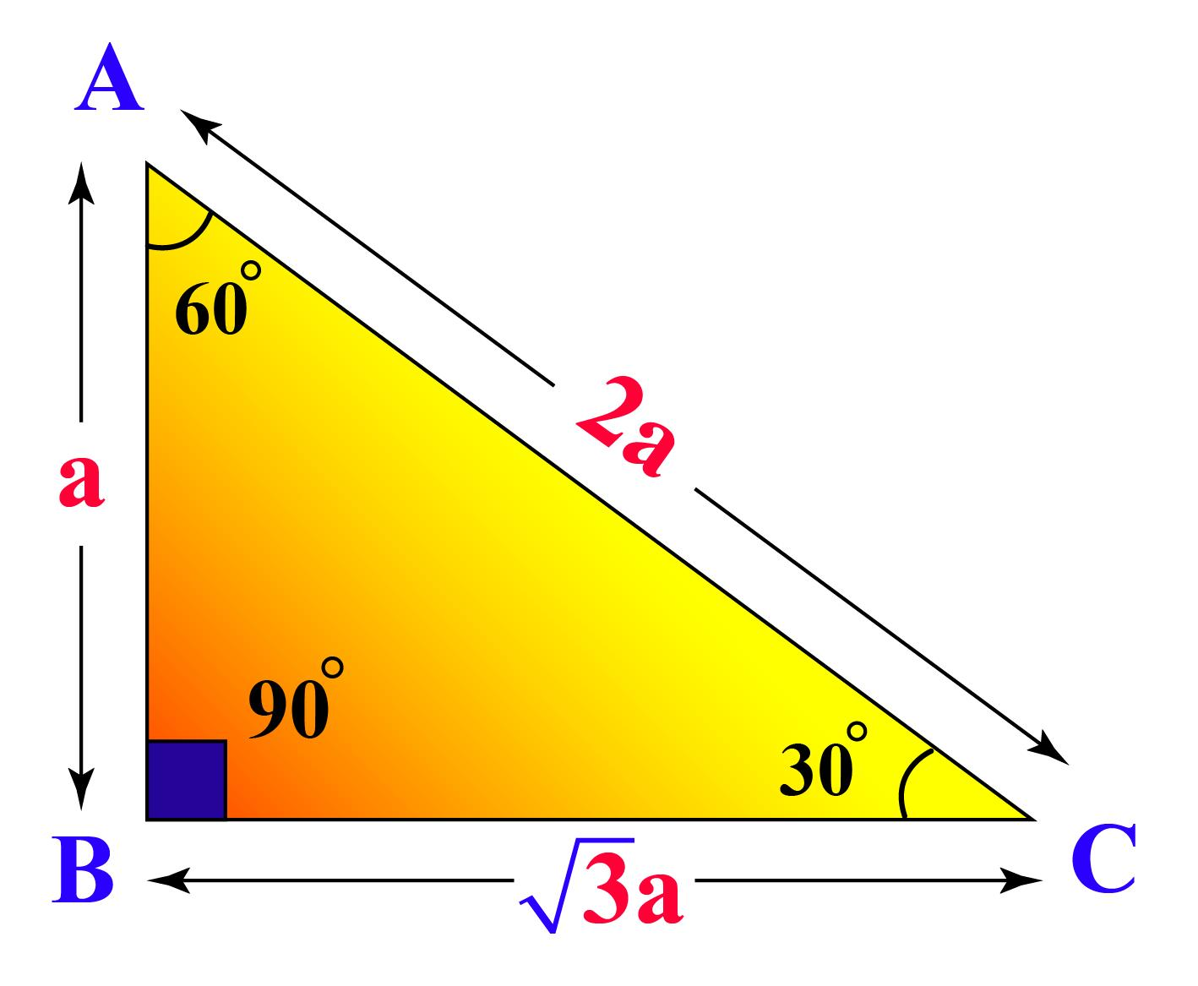
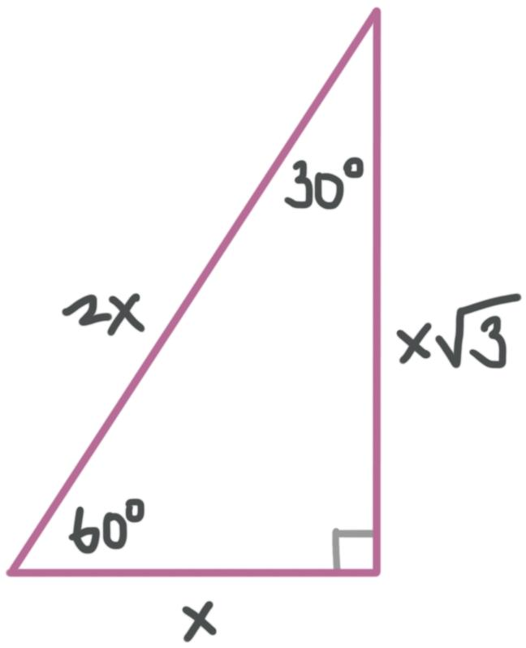
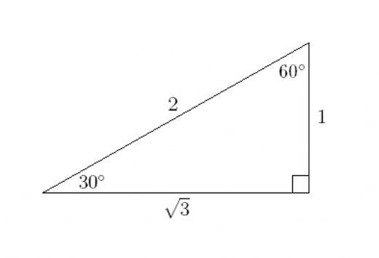

Heron's Formula
# Source: AI Source: Provided by: [Data Path: Persons Table -> ID Column: 1, Name_En Column: Motasem Essam] -> From: [ChatGPT] on [7/25/2026]
The area of a triangle can also be calculated when all three side lengths are known.
First calculate the semiperimeter:
$$\boxed{s=\frac{a+b+c}{2}}$$
Then:
$$\boxed{A=\sqrt{s\left(s-a\right)\left(s-b\right)\left(s-c\right)}}$$
This is called Heron's formula.
Example
For:
$$a=3, b=4, c=5$$
we have:
$$s=\frac{3+4+5}{2}=6$$
Therefore:
$$A=\sqrt{6\left(6-3\right)\left(6-4\right)\left(6-5\right)} \\ A=\sqrt{36} \\ \boxed{A=6}$$

Real-World Examples
# Source: AI Source: Provided by: [Data Path: Persons Table -> ID Column: 1, Name_En Column: Motasem Essam] -> From: [ChatGPT] on [7/25/2026]
Triangles appear in:
- Roof structures.
- Bridges.
- Towers.
- Trusses.
- Road signs.
- Building frames.
- Surveying.
- Navigation.
- Architecture.
- Mechanical structures.
- Computer graphics.
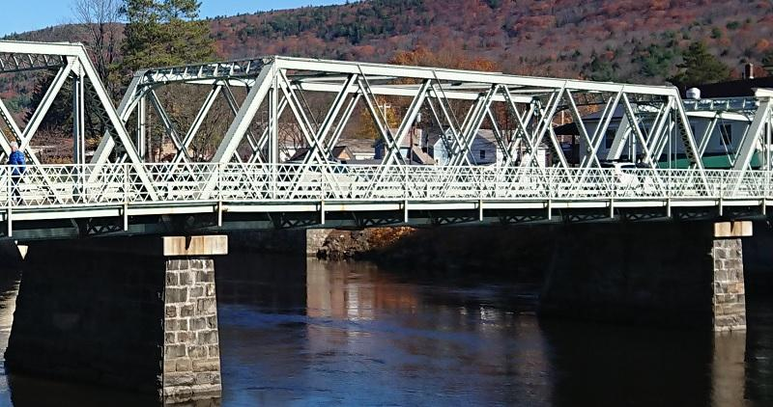
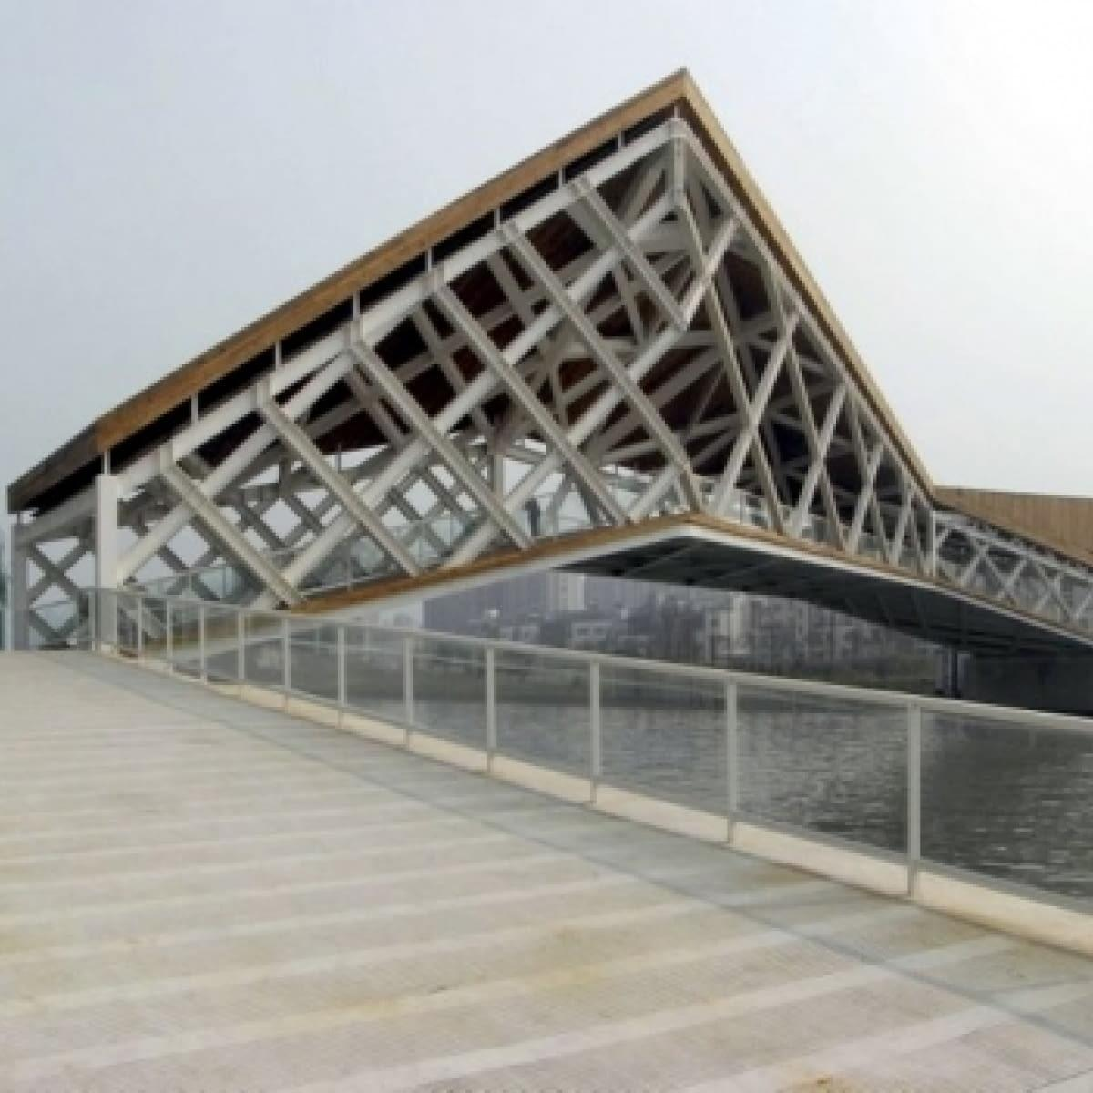
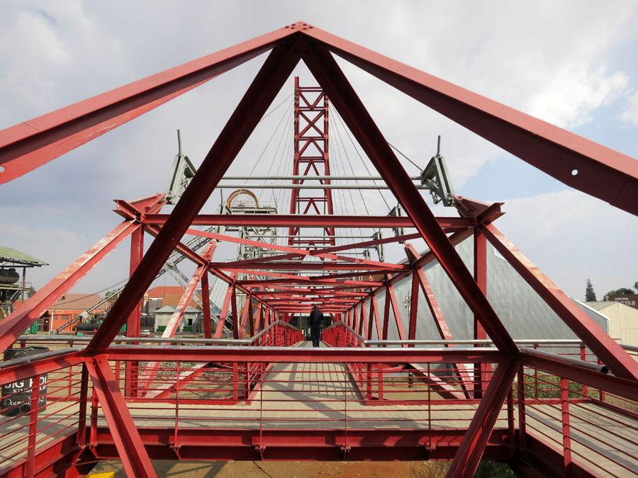

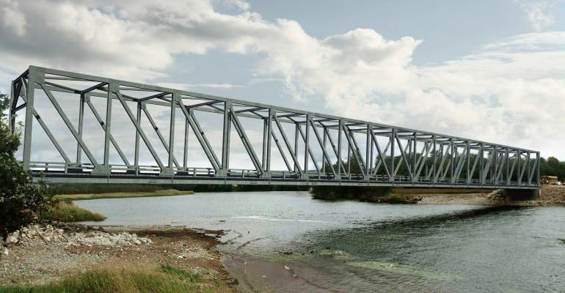

Applications
# Source: AI Source: Provided by: [Data Path: Persons Table -> ID Column: 1, Name_En Column: Motasem Essam] -> From: [ChatGPT] on [7/25/2026]
Triangles are fundamental in:
- Plane Geometry
- Trigonometry
- Coordinate Geometry
- Engineering
- Architecture
- Surveying
- Navigation
- Cartography
- Computer Graphics
- CAD
- Robotics
- Physics

Advantages
# Source: AI Source: Provided by: [Data Path: Persons Table -> ID Column: 1, Name_En Column: Motasem Essam] -> From: [ChatGPT] on [7/25/2026]
Studying triangles helps to:
- Develop geometric reasoning.
- Calculate distances.
- Calculate areas.
- Determine unknown angles.
- Analyze structures.
- Understand trigonometry.
- Study similarity and congruence.
- Solve coordinate geometry problems.
- Model real-world structures.

Limitations
# Source: AI Source: Provided by: [Data Path: Persons Table -> ID Column: 1, Name_En Column: Motasem Essam] -> From: [ChatGPT] on [7/25/2026]
A triangle:
- Has exactly three sides.
- Has exactly three vertices.
- Has exactly three interior angles.
- Is always a closed figure.
- Cannot represent shapes with four or more sides without decomposition.
- Has an interior angle sum fixed at ${180}^{∘}$.

Comparison with Related Polygons
# Source: AI Source: Provided by: [Data Path: Persons Table -> ID Column: 1, Name_En Column: Motasem Essam] -> From: [ChatGPT] on [7/25/2026]
Figure | Number of Sides | Number of Vertices | Interior Angle Sum
Triangle | 3 | 3 | $${180}^{∘}$$
Quadrilateral | 4 | 4 | $${360}^{∘}$$
Pentagon | 5 | 5 | $${540}^{∘}$$
Hexagon | 6 | 6 | $${720}^{∘}$$
The triangle is the simplest polygon.

Key Points
# Source: AI Source: Provided by: [Data Path: Persons Table -> ID Column: 1, Name_En Column: Motasem Essam] -> From: [ChatGPT] on [7/25/2026]
- A triangle is a polygon with exactly three sides.
- It has:
  - $3$sides
  - $3$vertices
  - $3$angles
- The interior angles always sum to:
$$\boxed{{180}^{∘}}$$
- Triangles are classified by sides as:
  - Equilateral
  - Isosceles
  - Scalene
- Triangles are classified by angles as:
  - Acute
  - Right
  - Obtuse
- The perimeter is:
$$\boxed{P=a+b+c}$$
- The area is:
$$\boxed{A=\frac{1}{2}bh}$$
- A right triangle follows:
$$\boxed{a^{2}+b^{2}=c^{2}}$$
- Every triangle has three:
  - Medians
  - Altitudes
  - Angle bisectors
  - Perpendicular bisectors
- Important triangle centers include:
  - Centroid
  - Orthocenter
  - Incenter
  - Circumcenter

Conclusion
# Source: AI Source: Provided by: [Data Path: Persons Table -> ID Column: 1, Name_En Column: Motasem Essam] -> From: [ChatGPT] on [7/25/2026]
A triangle is the simplest polygon in plane geometry, consisting of three line segments, three vertices, and three interior angles. Its fundamental properties make it one of the most important figures in mathematics.
Triangles can be classified by their side lengths as equilateral, isosceles, or scalene, and by their angle measures as acute, right, or obtuse. Their interior angles always satisfy:
$$\boxed{A+B+C={180}^{∘}}$$
The area of a triangle is:
$$\boxed{A=\frac{1}{2}bh}$$
and right triangles satisfy the Pythagorean theorem:
$$\boxed{a^{2}+b^{2}=c^{2}}$$
Triangles form the foundation of trigonometry, coordinate geometry, engineering, architecture, surveying, navigation, CAD, computer graphics, and structural design, making them one of the most fundamental concepts in plane geometry.

